

**SOFTWARE ENGINEERING**

**TEST PLAN DOCUMENT**

**ACADEMIC MANAGEMENT SYSTEM**

**GROUP MEMBERS :**

Rahul Kumar ( IIT2019109)

Aditya Singh Machhaiya ( IIT2019111 )

Khushi Gupta ( IIT2019141 )

Nandini Gupta ( IIT2019149 )

**Table of Contents**

**TEST DOCUMENT:**

**Academic Management System……..................................................................1**

**Section 1: Introduction........................................................................................4 Section 2: Unit testing.........................................................................................5 Test Case 1: Welcome page................................................................................6 Test Case 2: Student login..................................................................................7 Test Case 3: Student forgot password page.....................................................8 Test Case 4: Student Registration page............................................................9 Test Case 5: Student home page......................................................................10 Test Case 6: Academic calendar.......................................................................11 Test Case 7: Class time table............................................................................12 Test Case 8: Student Status..............................................................................13 Test Case 9: Fee Status.....................................................................................14 Test Case 10: Student Profile............................................................................15 Test Case 11: Core Subject.................................................................................6 Test Case 12:(Student) Course coordinator.....................................................7 Test Case 13: Semester Results.........................................................................8 Test Case 14: Dean/Admin Login.......................................................................9 Test Case 15: Dean/Admin Forgot Password..................................................10 Test Case 16: Dean/Admin Registration..........................................................11 Test Case 17: Dean/Admin Home.....................................................................12 Test Case 18: Academic calendar.....................................................................13 Test Case 19: Time table...................................................................................14 Test Case 20: Search Student...........................................................................15 Test Case 21: View Student Information..........................................................10 Test Case 22: Search Result.............................................................................11 Test Case 23: View Student Marks...................................................................12 Test Case 24: Student Profile update...............................................................13 Test Case 25: (Dean )Course Coordinator.......................................................14**

**SECTION 1: INTRODUCTION**

This is the Test Execution Document of the web application, Academic Management System, a Software Engineering project at the Information Technology Department of IIIT, Allahabad, Prayagraj, Rajasthan.It is a web application meant for dean and students of IIIT-A exclusively to see their academic related details and update them.. This document presents the results of the execution of the different tests presented in this test plan document. The document is organized as follows:

* Section 1 is the Introduction itself.
* Section 2 introduces the results of Unit testing
* Section 3 introduces the results of Integration testing.
* Section 4 introduces the results of System testing.
* Section 5 describes the bugs found during the test phase, are listed.

The results of the test execution will be presented in subsection as follows:

* Id and name of the executed test.
* Description of the test, or collected results.
* Errors found if any, and maybe a reference to the bug and fixes report. If error was found on a certain step of Test Case, the step number is given.

All test cases were first executed once and found bugs were fixed. Then all test cases were executed again and no further bugs were found.

**SECTION 2: UNIT TESTING**

Since we are working on a web application, Unit tests were created as screenshots of all the visible interfaces. Each minute component has been checked for its function for e.g. every button’s activity has been captured and shown as a test case.

|  |  |  |
| --- | --- | --- |
| Test Cases | | |
| Test case no. | Name | Test case |
| 1 | Welcome | Check if the welcome page opens on starting the application |
| 2 | Student Login | Initial Login page to check if the student can log into the system |
| 3 | Student Forgot Password | The page where the student can change the password in case he/she forgets it |
| 4 | Student Registration | The page where a new student can register into the system |
| 5 | Student Home | The page that opens once the student log into the system |
| 6 | Academic Calendar | The page where student can see the current academic calendar |
| 7 | Class Timetable | The page where student can see the current class timetable |
| 8 | Student Status | The page where students can see his/her status related to CGPA , attendance,etc. |
| 9 | Fees status | The page provides the fees related information of that particular student. |
| 10 | Student Profile | The page where student can see the current academic calendar |
| 11 | Core subjects | The page where the student can see his/her subjects, electives as well as projects |
| 12 | (Student ) Course Coordinators | The page where student can see the list of coordinators |
| 13 | Semester Results | The page where the student can see the semester results and download them as well |
| 14 | Complete Subjects | The page where the student can see the semester wise subjects. |
| 15 | Dean/admin Login | Initial Login page to check if the dean/admin can log into the system |
| 16 | Dean/admin Forgot Password | The page where the dean/admin can change the password in case he/she forgets it |
| 17 | Dean/admin Registration | The page where a new dean/student can register into the system |
| 18 | Dean/admin Home | The page that opens once the dean/admin log into the system |
| 19 | Calendar | The page where dean/admin can see the current academic calendar and update the existing one |
| 20 | Timetable | The page where dean/admin can see the current timetable and update the existing one |
| 21 | Search Student | The page where dean/admin can search for a student by entering the username |
| 22 | View Student Information | The page where the dean/admin gets the information of the specified student |
| 23 | Search Result | The page where dean/admin can search for the marks of a student by entering the username |
| 24 | View Student marks | The page where the dean/admin gets the marks of the specified student |
| 25 | Student Profile update | The page where dean/admin can make changes to the profile of a student and update them in the database |
| 26 | (Dean ) Course coordinator | The page where dean/admin can see the list of coordinators |
| 27 | Search Subject | The page where the dean/admin can see the list of students enrolled in that course. |

**TEST CASE 1:**

**Welcome page**

This is the initial page of the Academic Management System where the user can select his role. The welcome screen opens when the web application is started.

When the application is started the user is redirected to the welcome screen, this shows that the test case has passed.



**TEST CASE 2:**

**Student login**

This is the initial login page to check if the student can log in to the application or not. After a student has entered its login credentials, it must successfully log in the user to the home page.

When the Admin, who is using the application, enters the credentials and clicks on the ‘Login’ button, he is redirected into the next page, student home page.

This shows that the test case 2 has passed.

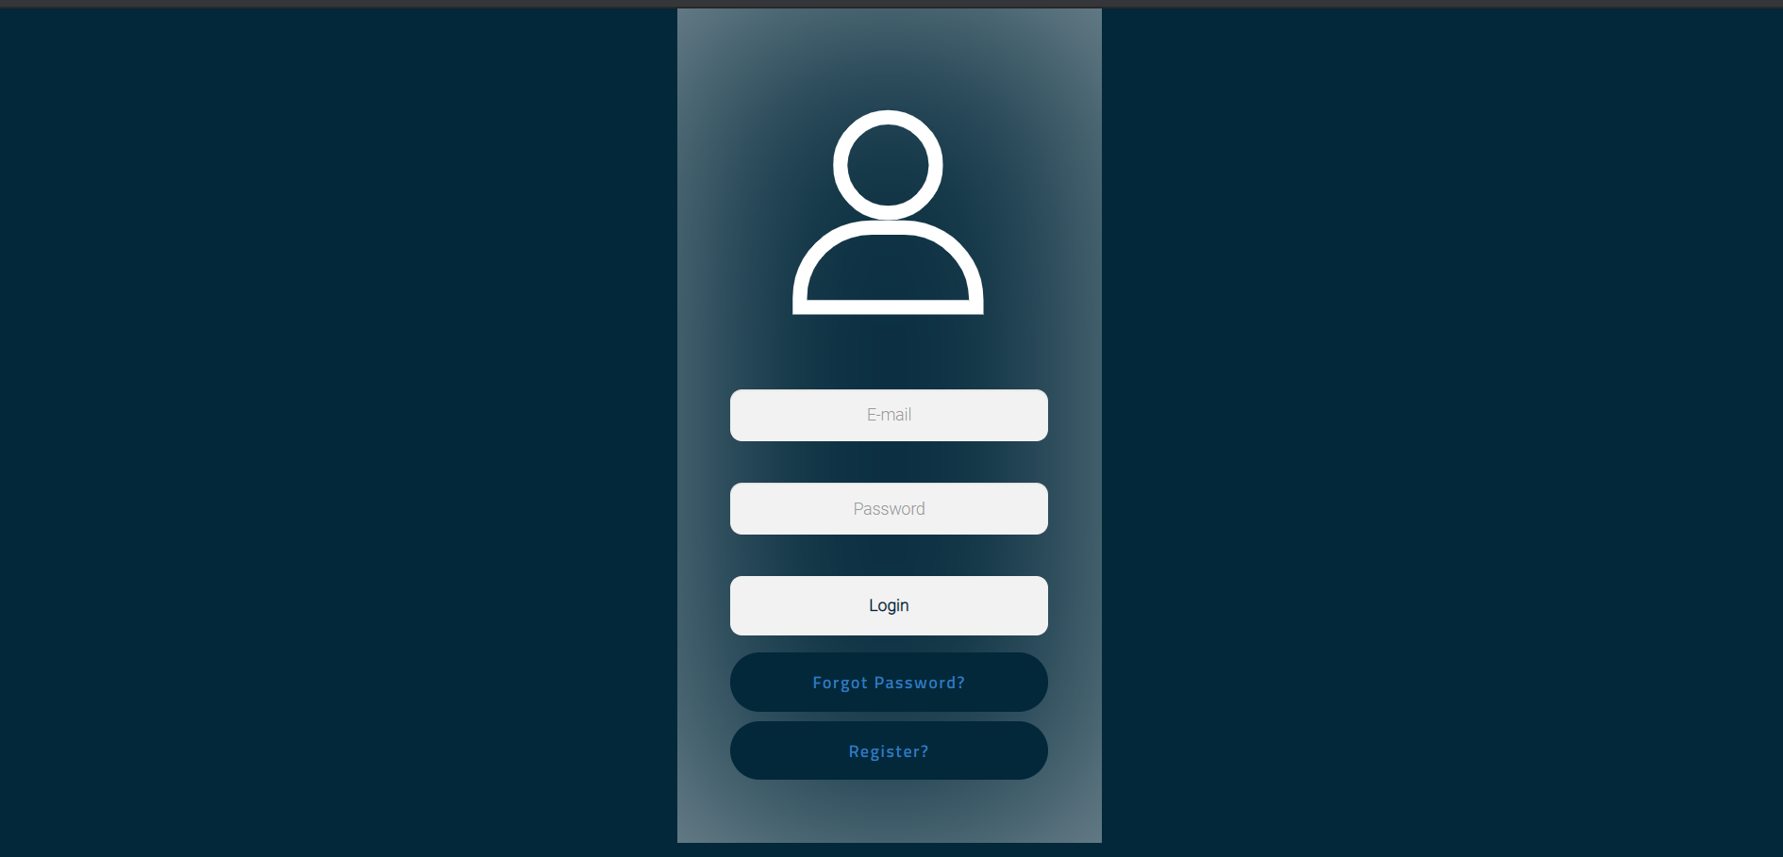



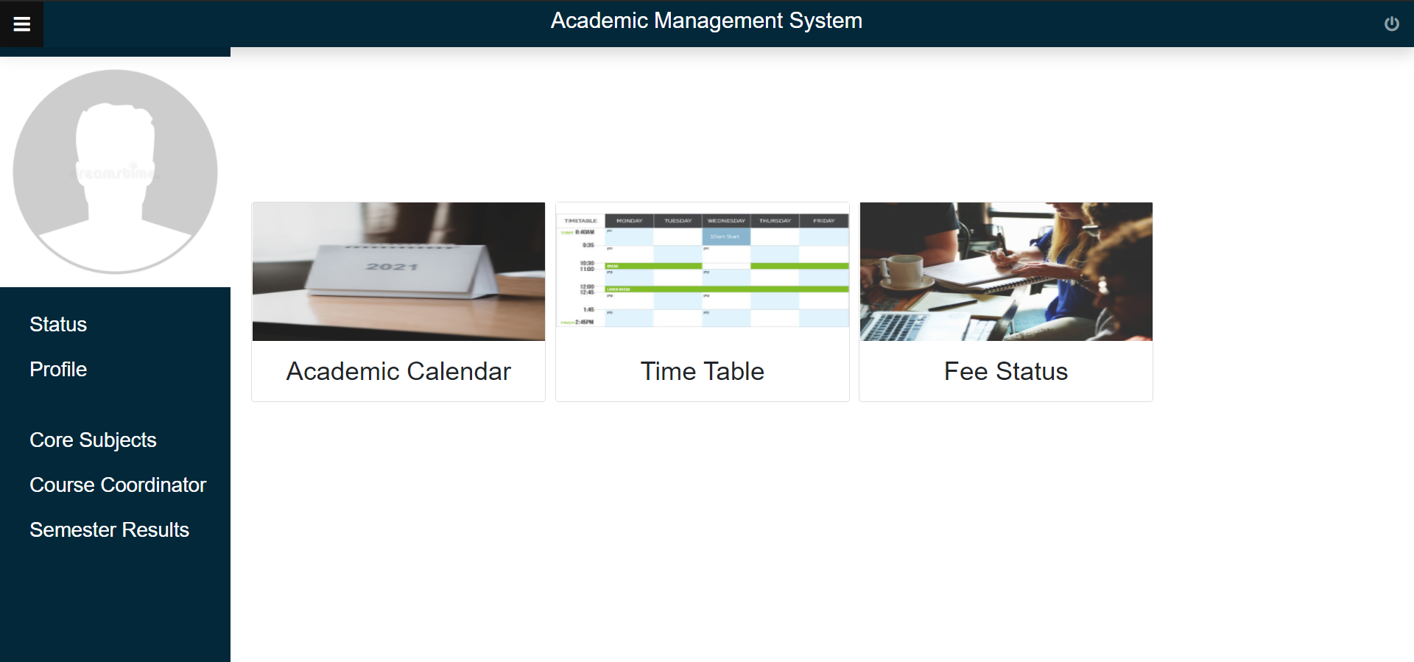

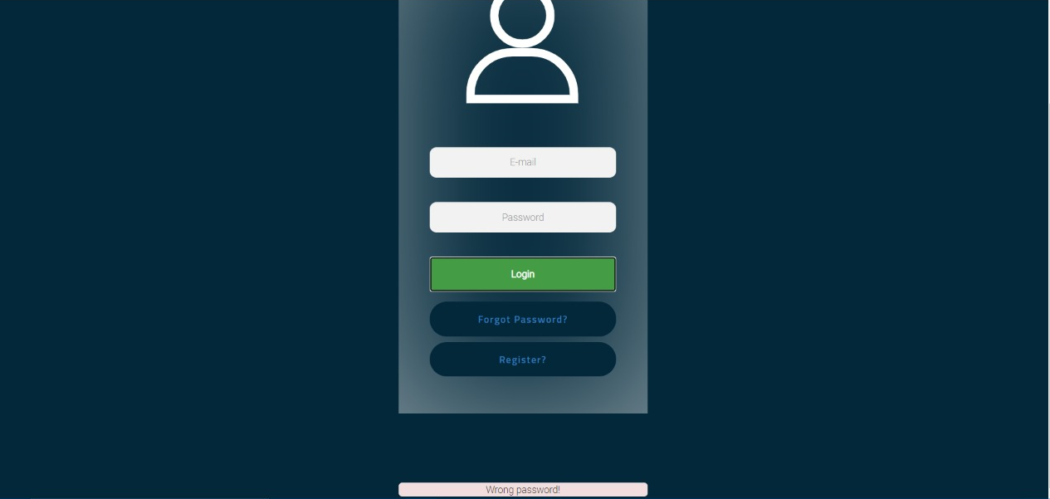

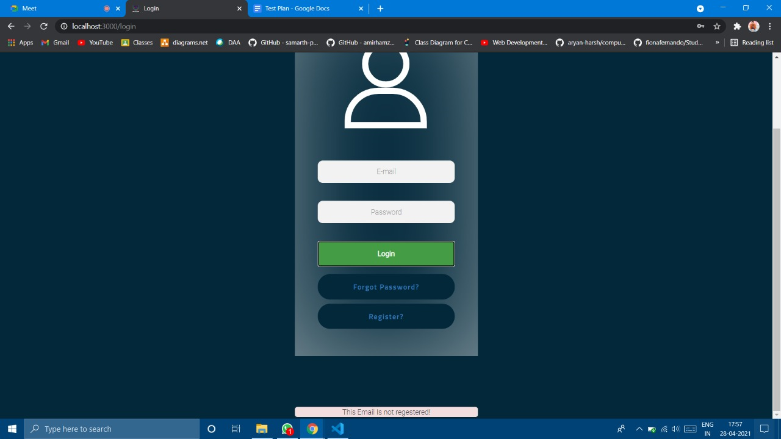

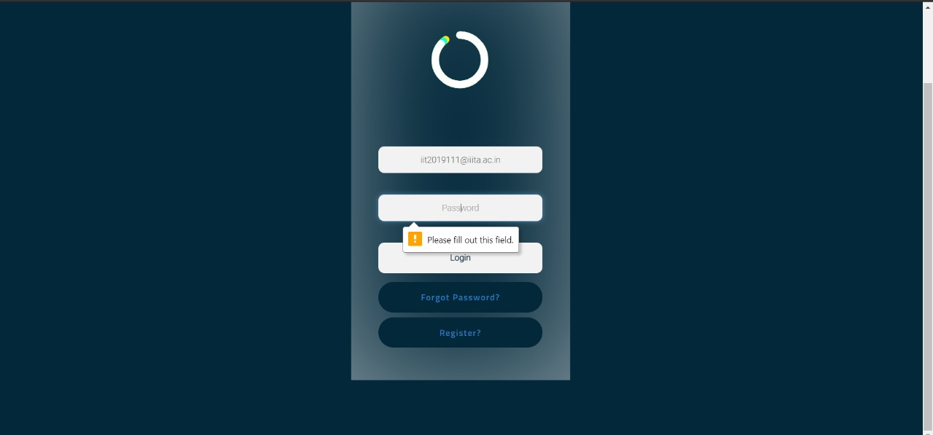

**TEST CASE 3:**

**Student forgot password page**

This is the forgot password page for the student in case he has forgotten his login credentials. He can set a new password and can then login into the application using the new password.

When the student, who is using the application, enters the new credentials and clicks on the ‘Login’ button, he is redirected into the next page, student home page.

This shows that the test case 3 has passed.





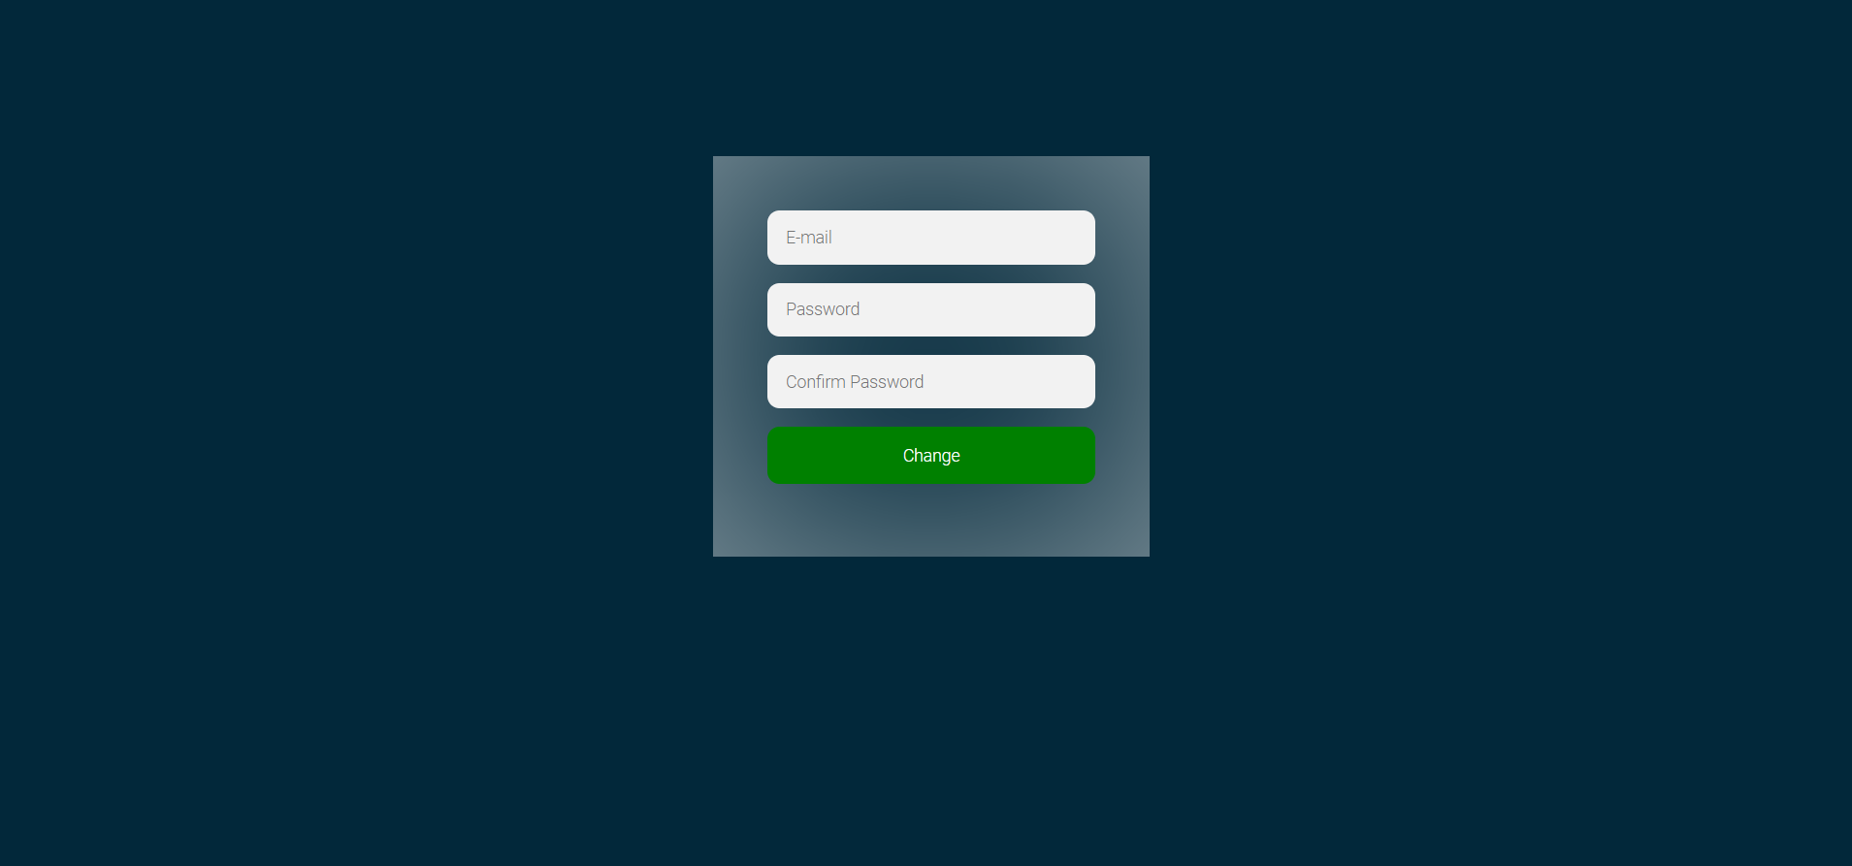









**TEST CASE 4:**

**Student Registration page**

This is the student registration page for the student to enable the student to register himself into the system and use it’s features. He can set a new username and password and can then login into the application using the credentials.

When the student, who is using the application, enters the credentials and clicks on the ‘Login’ button, he is redirected into the next page, student home page.

This shows that the test case 4 has passed.





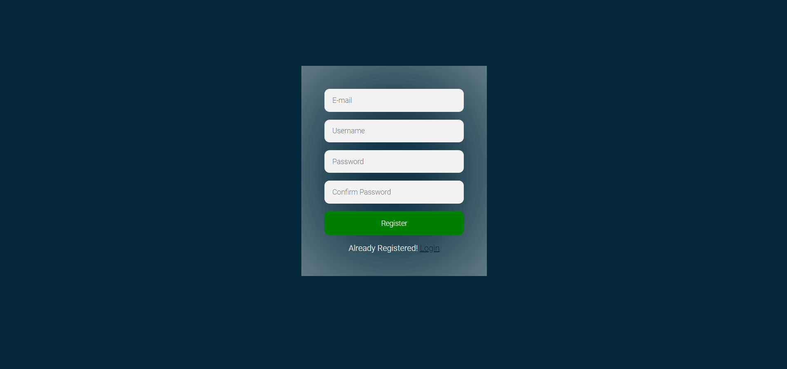









**TEST CASE 5:**

**Student home page**

This is the home page for the student. This page opens when the student logs into the web application by clicking on the Login button.

This shows that the test case 5 has passed.



**TEST CASE 6:**

**Academic calendar**

In the home screen the student can view the academic calendar, timetable and fees status.

When the student clicks on the academic calendar, he is redirected to the academic calendar of that particular batch which is in the form of a PDF document.

This shows that the test case 6 has passed.





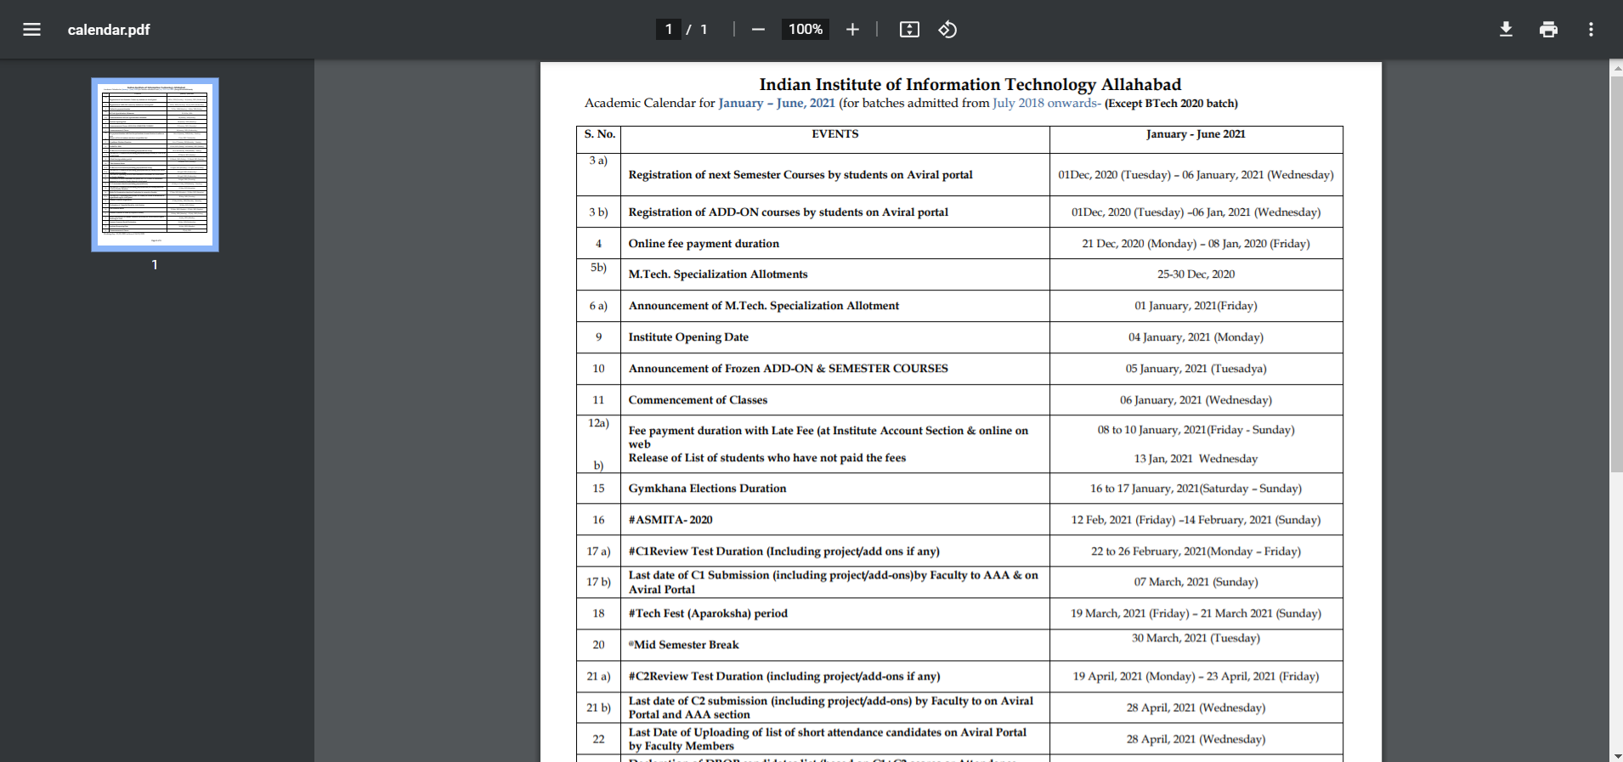

**TEST CASE 7:**

**Class time table**

In the home screen the student can view the academic calendar, timetable and fees status.

When the student clicks on the class timetable, he is redirected to the timetable of that particular semester which is in the form of a PDF document.

This shows that the test case 7 has passed.





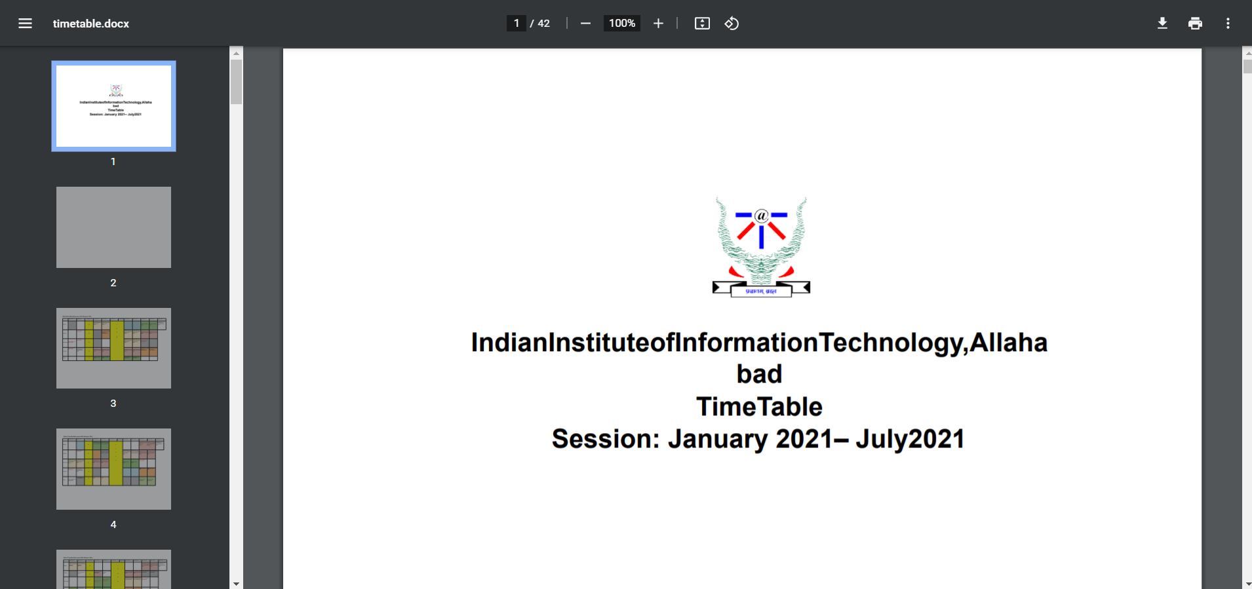

**TEST CASE 8:**

**Student Status**

In the home screen the student has been provided with multiple options in the sidebar.

When the student clicks on the status, he is redirected to the page that contains the information such as CGPA, attendance, dropped courses and penalty.

This shows that the test case 8 has passed.





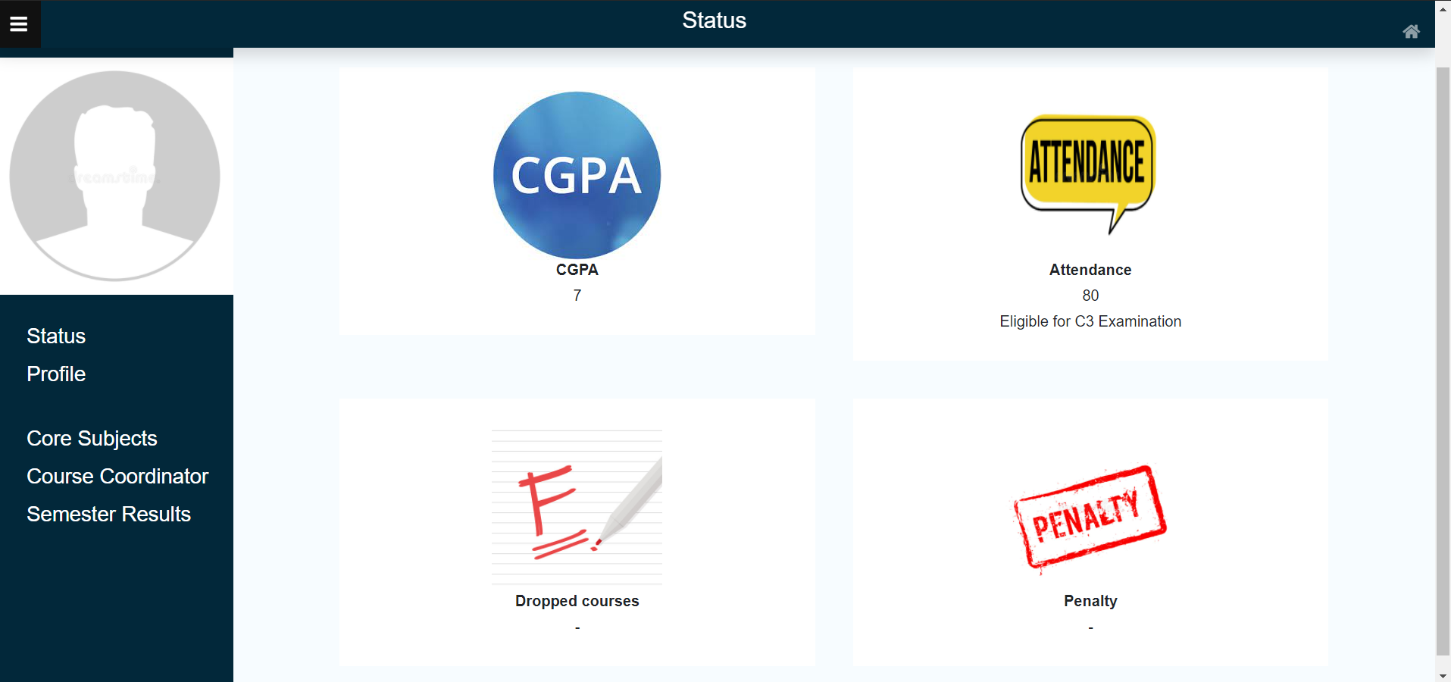

**TEST CASE 9:**

**Fee Status**

In the home screen the student can view the academic calendar, timetable and fees status.

When the student clicks on the fee status, he is redirected to the fees status of that particular semester.

This shows that the test case 9 has passed.





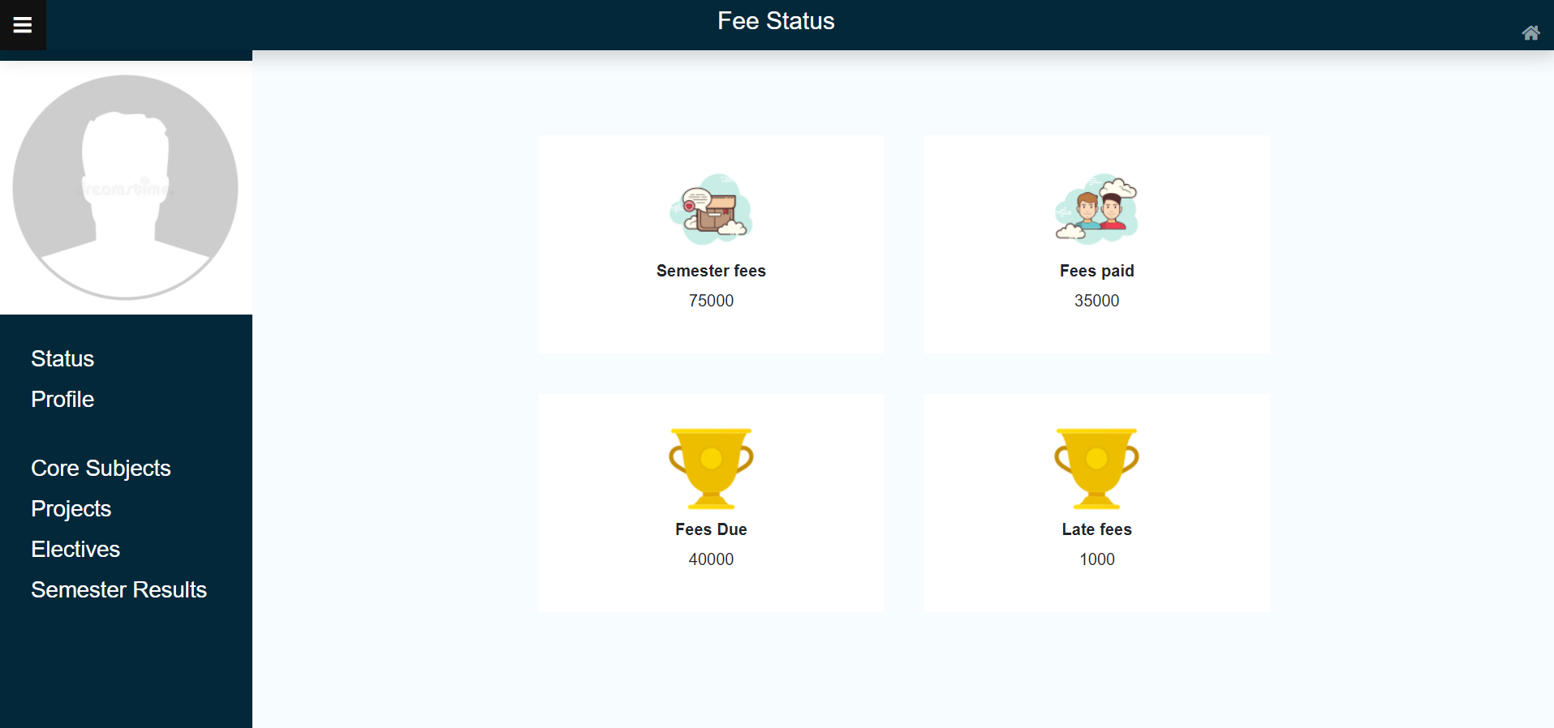

**TEST CASE 10:**

**Student Profile**

In the home screen the student has been provided with multiple options in the sidebar.

When the student clicks on the profile, he is redirected to the page that contains the entire profile that contains the general information about the student.

This shows that the test case 10 has passed.





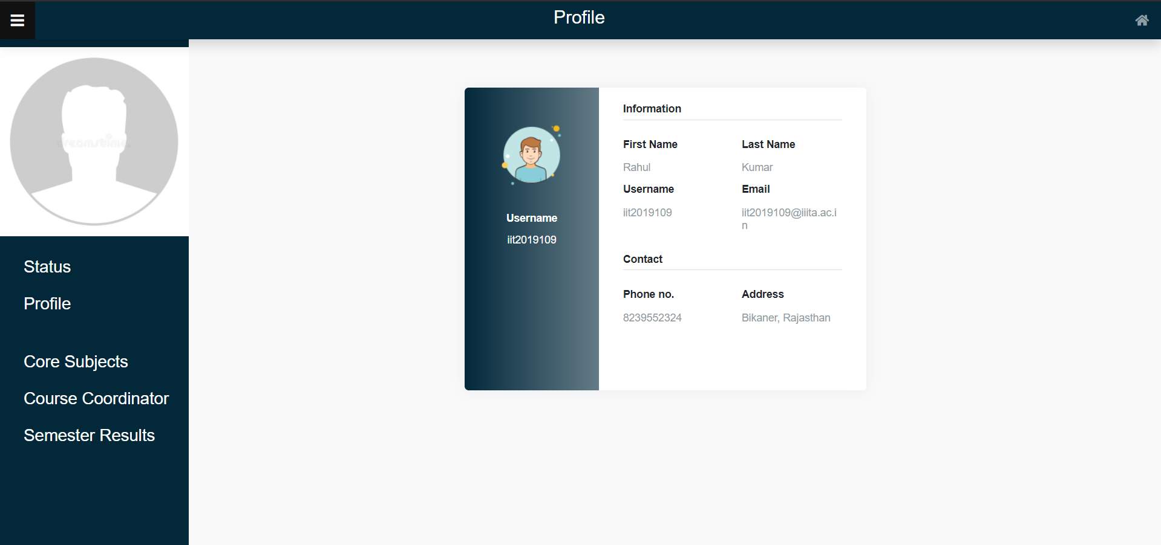

**TEST CASE 11:**

**Core Subject**

In the home screen the student has been provided with multiple options in the sidebar.

When the student clicks on the core subjects, he is redirected to the page that contains all the subjects, electives and projects.

This shows that the test case 11 has passed.





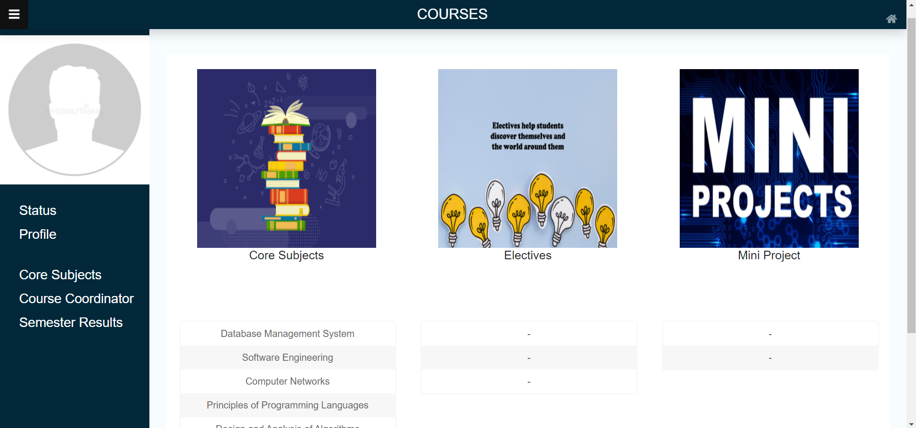

**TEST CASE 12:**

**Course Coordinator**

In the home screen the student has been provided with multiple options in the sidebar.

When the student clicks on the course coordinators, he is redirected to the page that contains the list of all the coordinators, and clicking on any one of them redirects you to their profile page.

This shows that the test case 12 has passed.





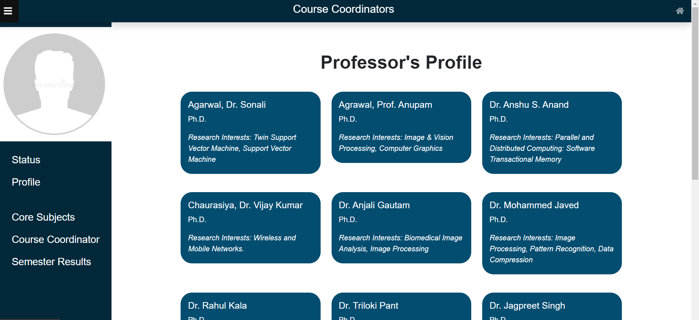

**Test Case 13:**

**Semester Results**

In the home screen the student has been provided with multiple options in the sidebar.

When the student clicks on the semester results, he is redirected to the page that contains the component-wise marks of all the subjects, electives and projects.Further, these results can be downloaded in png format.

This shows that the test case 13 has passed.





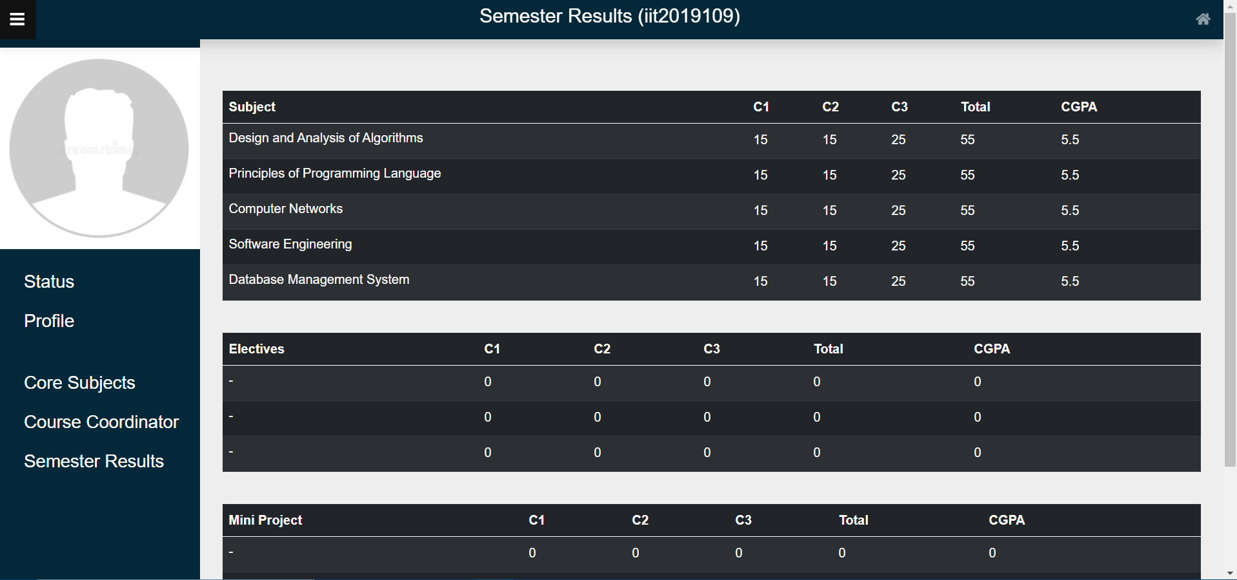

**Test Case 14:**

**Complete Subjects**

In the home screen the student has been provided with multiple options in the sidebar.

When the student clicks on the complete subjects, he is redirected to the page that contains the semester-wise subjects of all the semesters.

This shows that the test case 14 has passed.

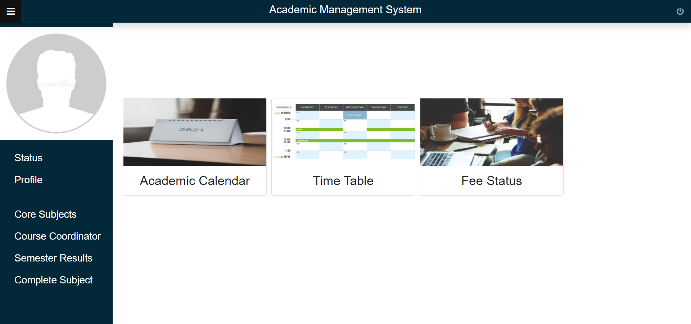



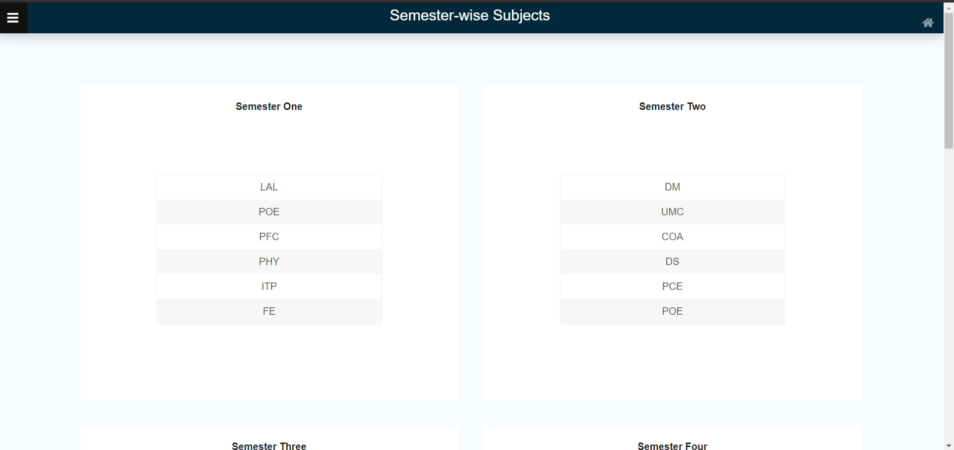

**Test Case 15:**

**Dean/Admin Login**

This is the initial login page to check if the dean can log in to the application or not. After the dean has entered its login credentials, it must successfully log in the user to the home page.

When the dean/admin, who is using the application, enters the credentials and clicks on the ‘Login’ button, he is redirected into the next page, dean home page.

This shows that the test case 15 has passed.





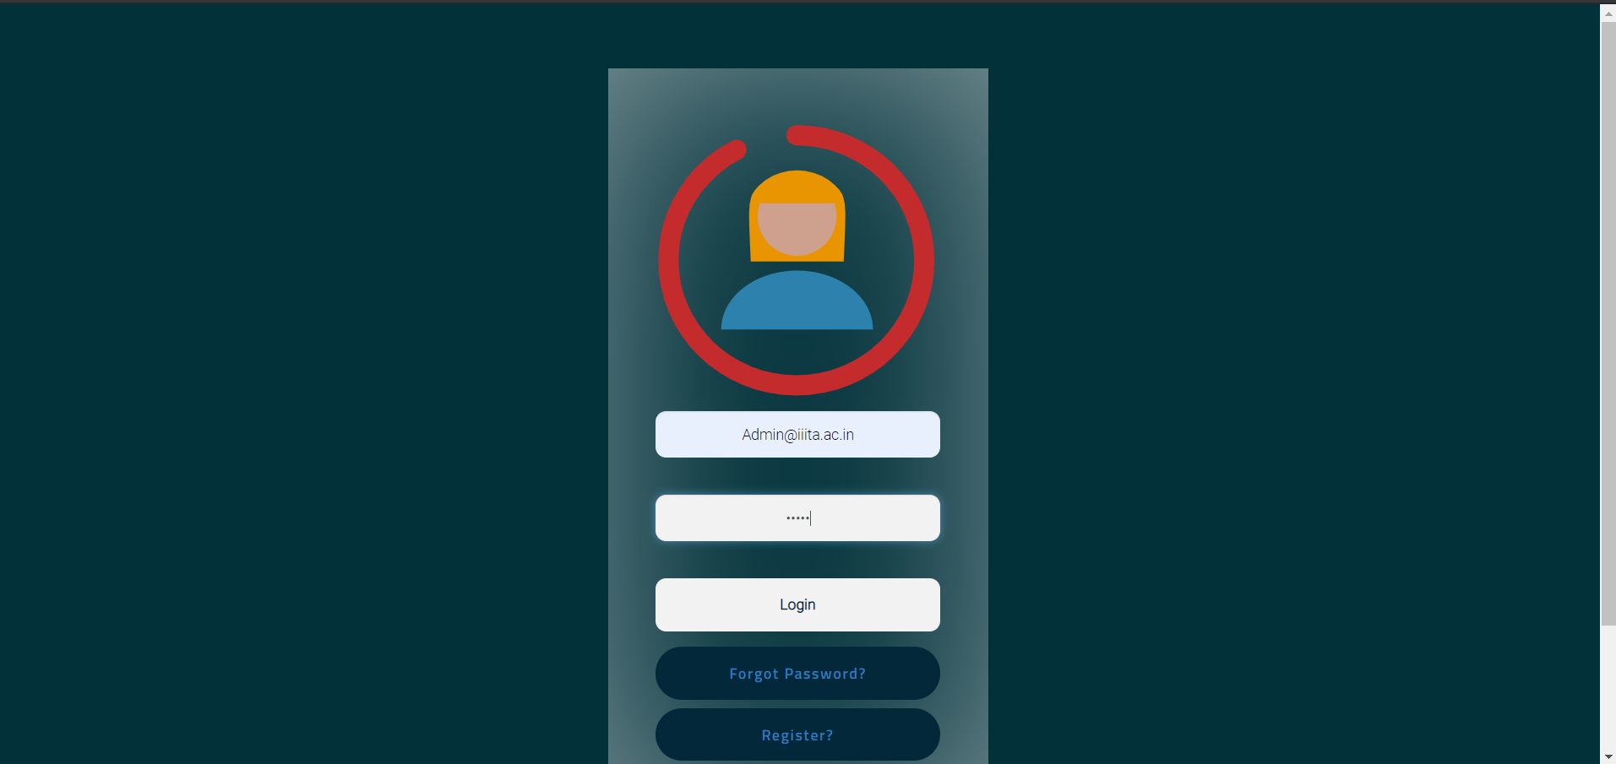

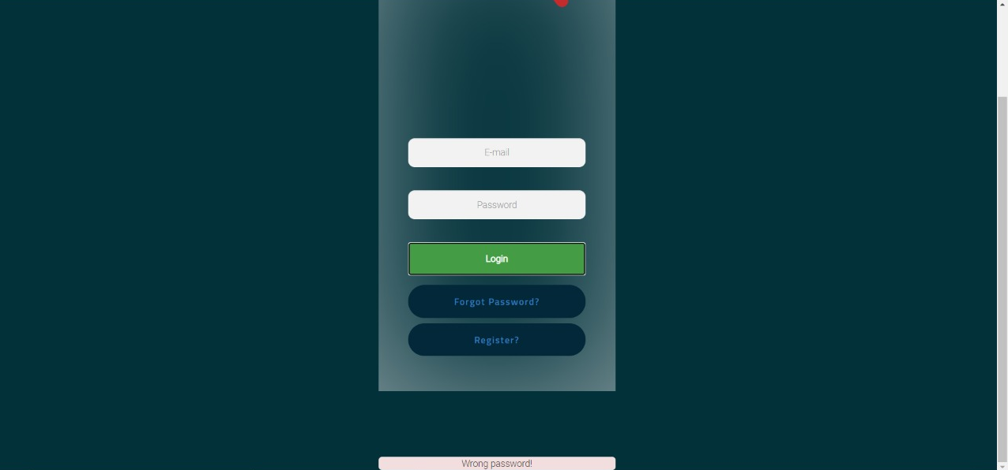

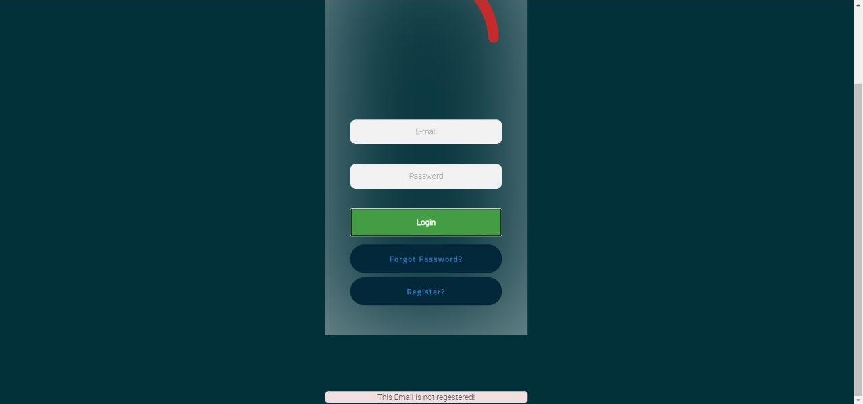

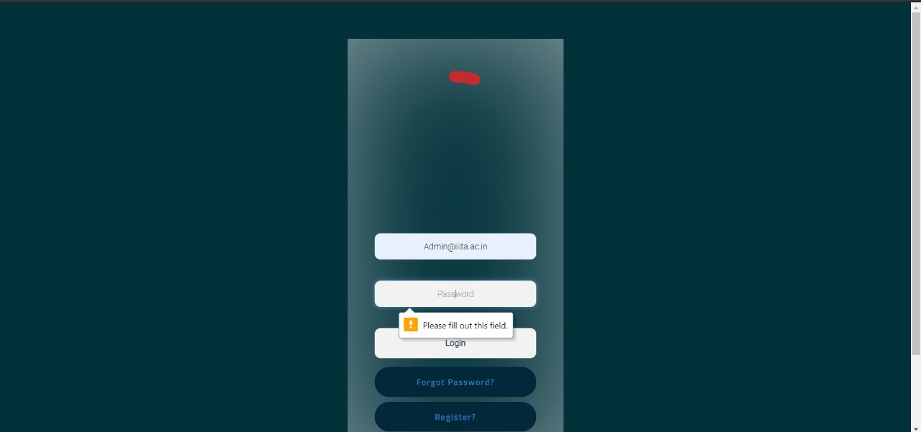

**Test Case 16:**

**Dean/Admin Forgot Password**

This is the forgot password page for the dean/admin in case he has forgotten his login credentials. He can set a new password and can then login into the application using the new password.

When the dean/admin, who is using the application, enters the new credentials and clicks on the ‘Login’ button, he is redirected into the next page, dean home page.

This shows that the test case 16 has passed.

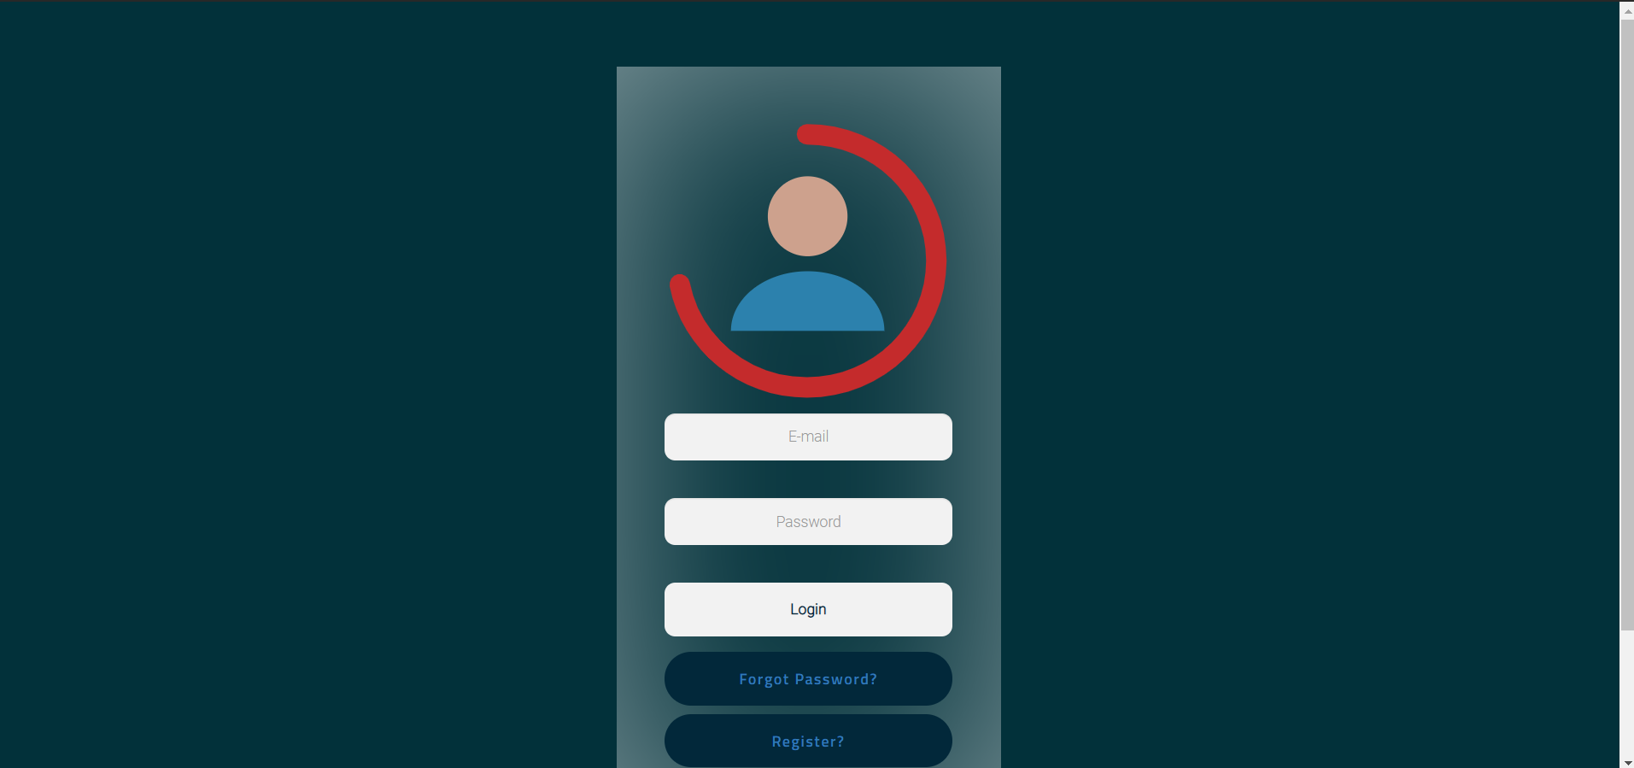



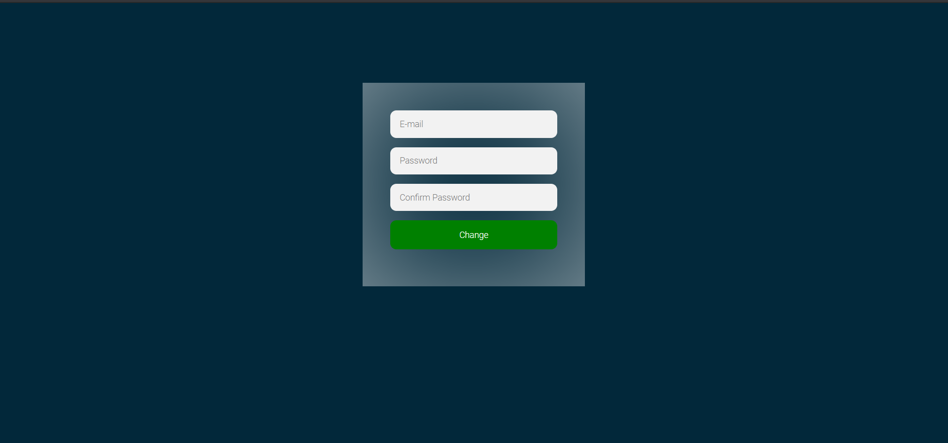







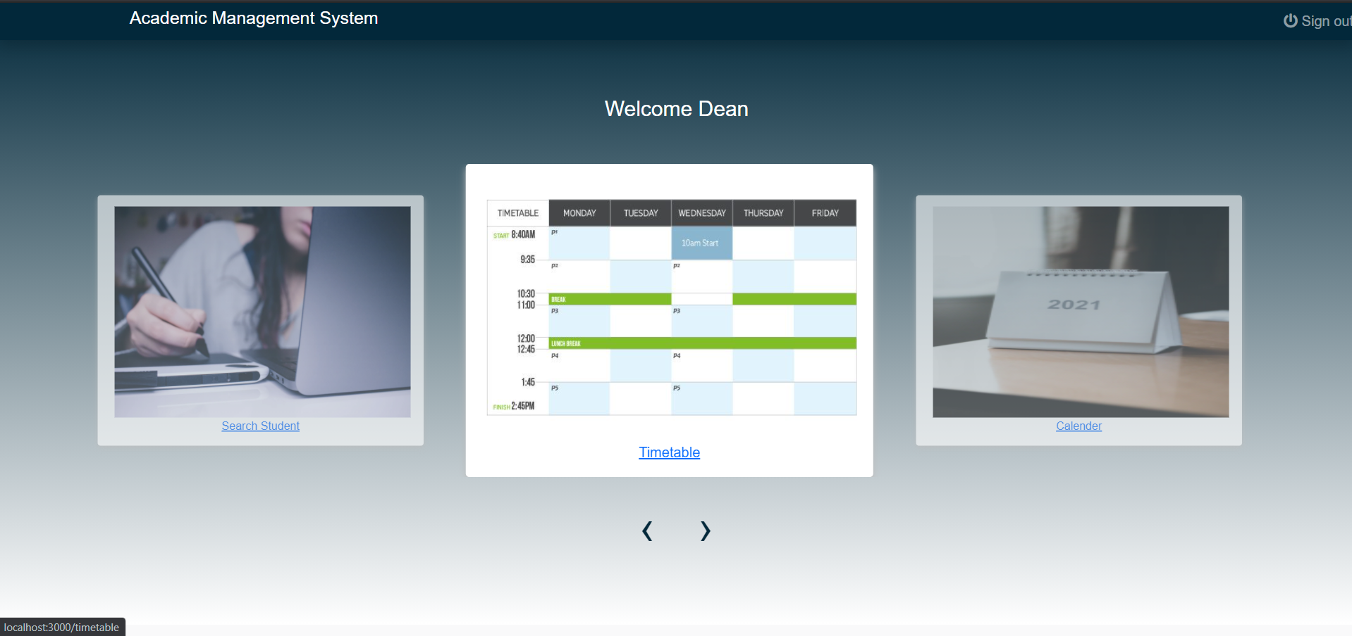

**Test Case 17:**

**Dean/Admin Registration**

This is the dean/admin registration page for the dean/admin to enable the dean/admin to register himself into the system and use it’s features. He can set a new username and password and can then login into the application using the credentials.

When the dean/admin, who is using the application, enters the credentials and clicks on the ‘Login’ button, he is redirected into the next page, dean home page.

This shows that the test case 17 has passed.





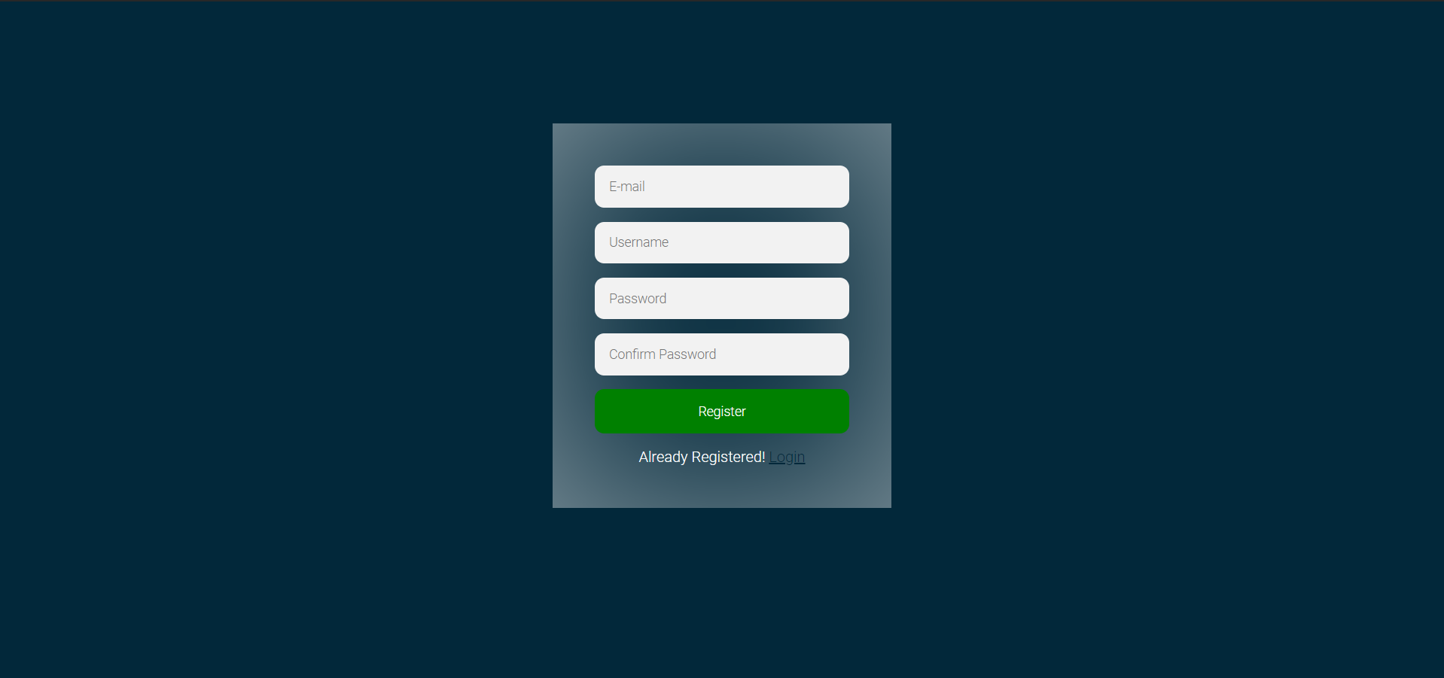









**Test Case 18:**

**Dean/Admin Home**

This is the home page for the dean/admin. This page opens when the dean/admin logs into the web application by clicking on the Login button.

This shows that the test case 18 has passed.







**Test Case 19:**

**Academic calendar**

The home page for the dean/admin contains multiple options to view and update details such as calendar, timetable, search student.

When we click on the calendar, we are redirected to a page that contains two options :

* View calendar
* Update calendar

If the dean/admin doesn’t upload any pdf from the computer, it shows a message- “Please upload a file.”

This shows that the test case 19 has passed.

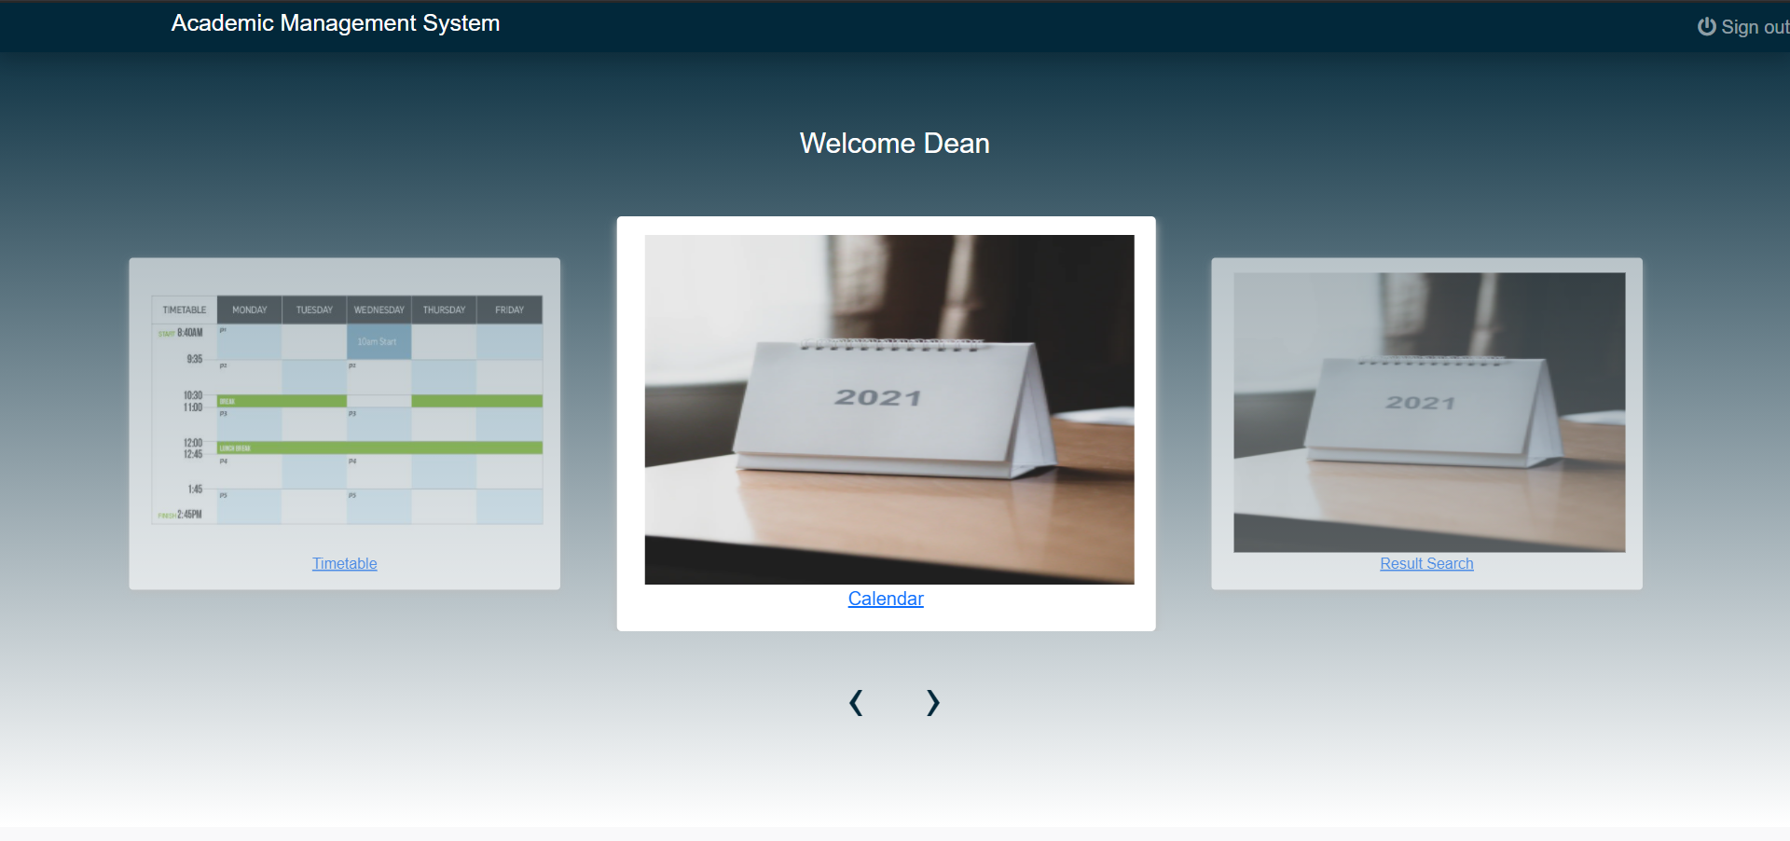



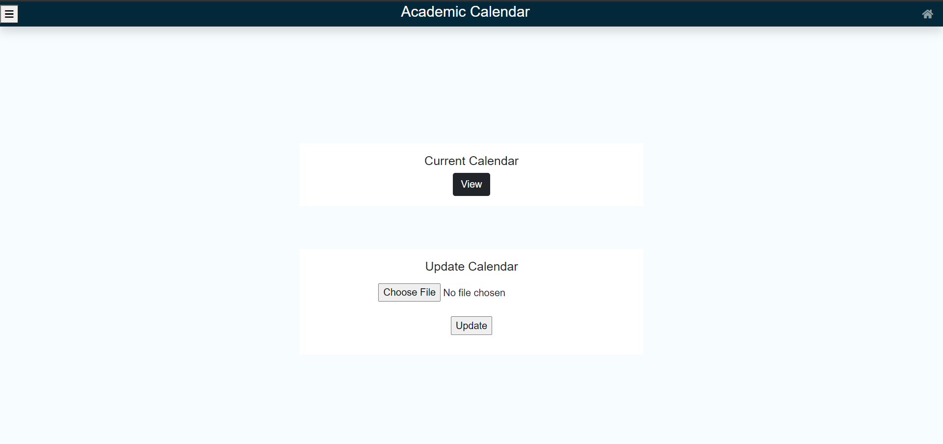



**Test Case 20:**

**Time table**

The home page for the dean/admin contains multiple options to view and update details such as calendar, timetable, search student.

When we click on the timetable, we are redirected to a page that contains two options :

* View timetable
* Update timetable

If the dean/admin doesn’t upload any pdf from the computer, it shows a message- “Please upload a file.”

This shows that the test case 20 has passed.

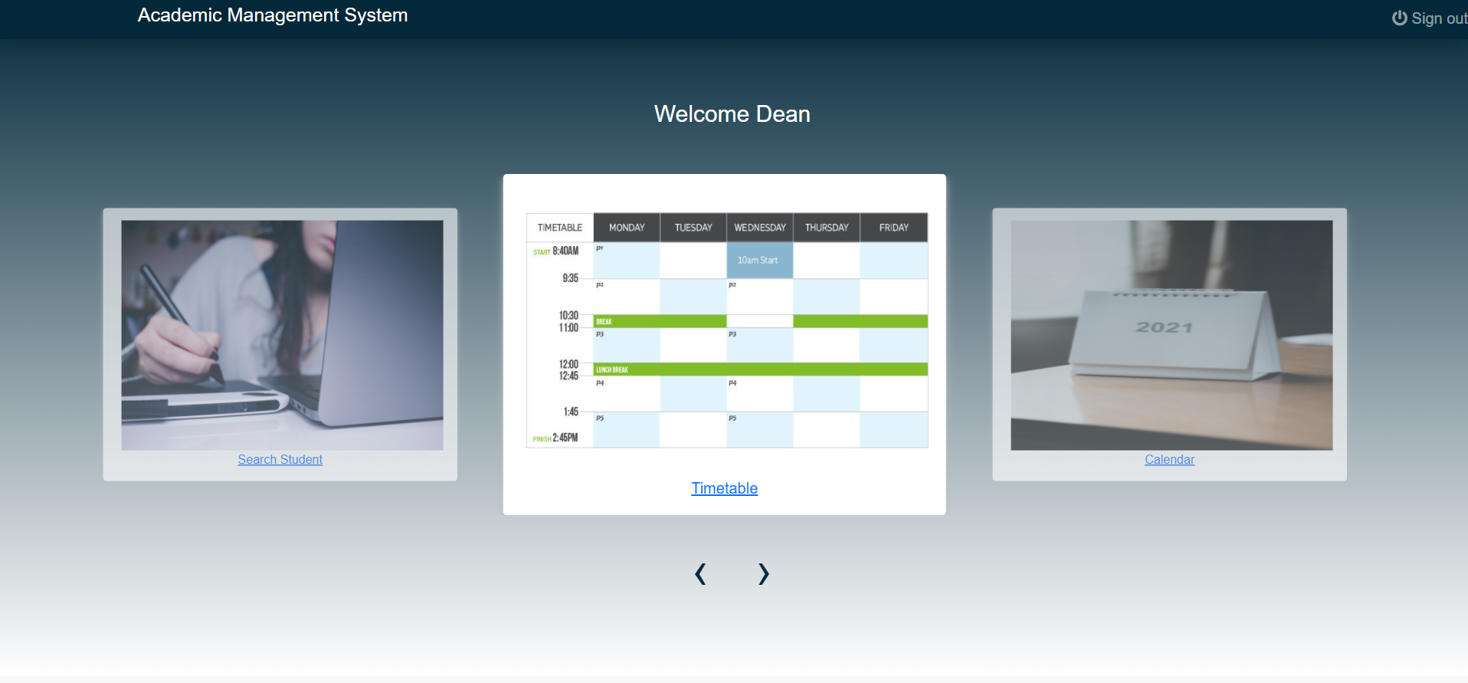



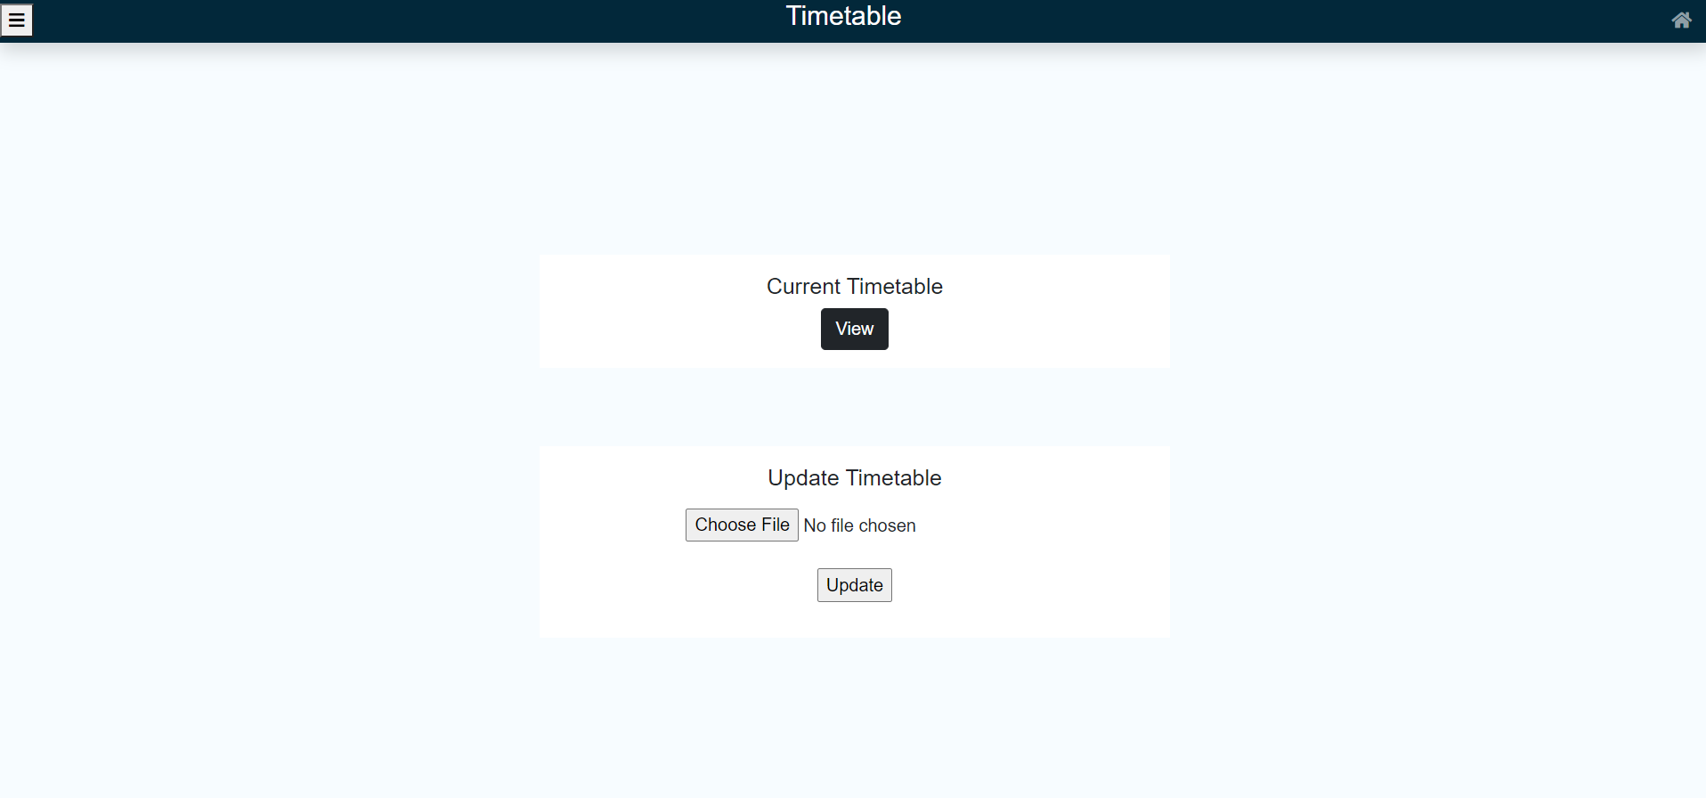



**Test Case 21:**

**Search Student**

The home page for the dean/admin contains multiple options to view and update details such as calendar, timetable, search student.

When we click on the search student, we are redirected to a page that contains an option to enter the student username and search for that particular username

If the student entered by the dean is not present in the database , then it shows a message that the student is not registered.

This shows that the test case 21 has passed.

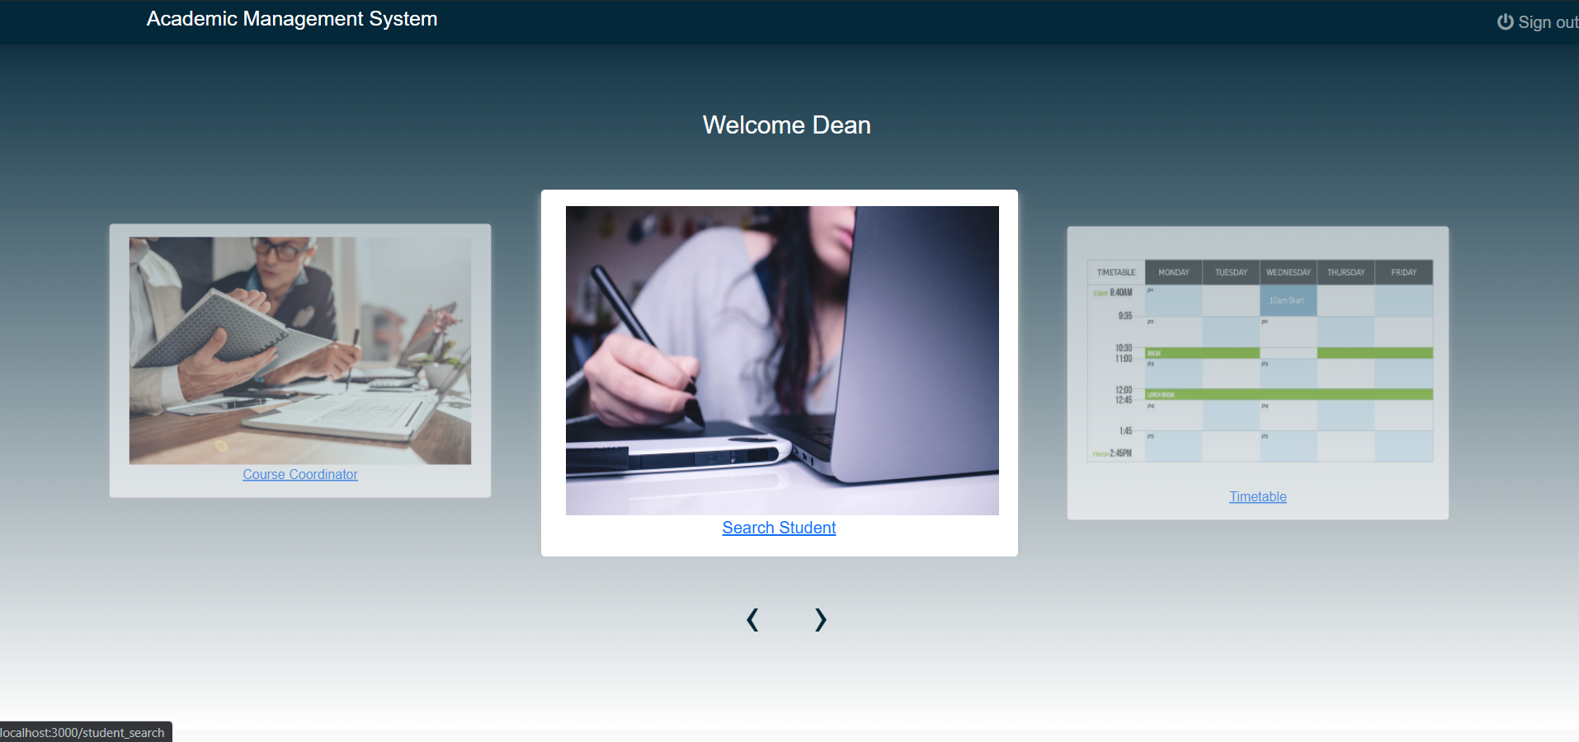



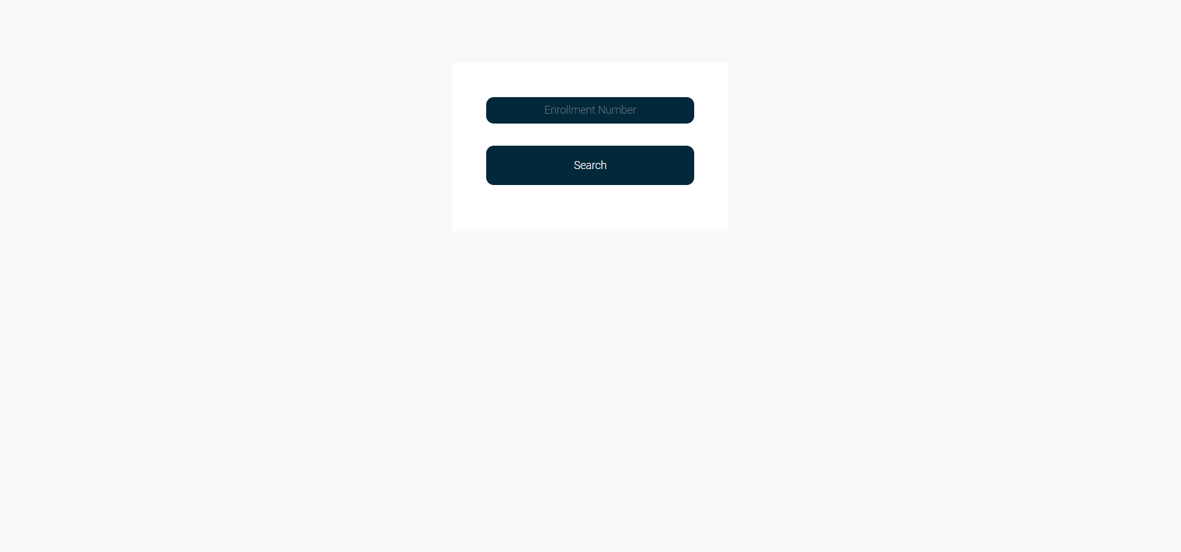

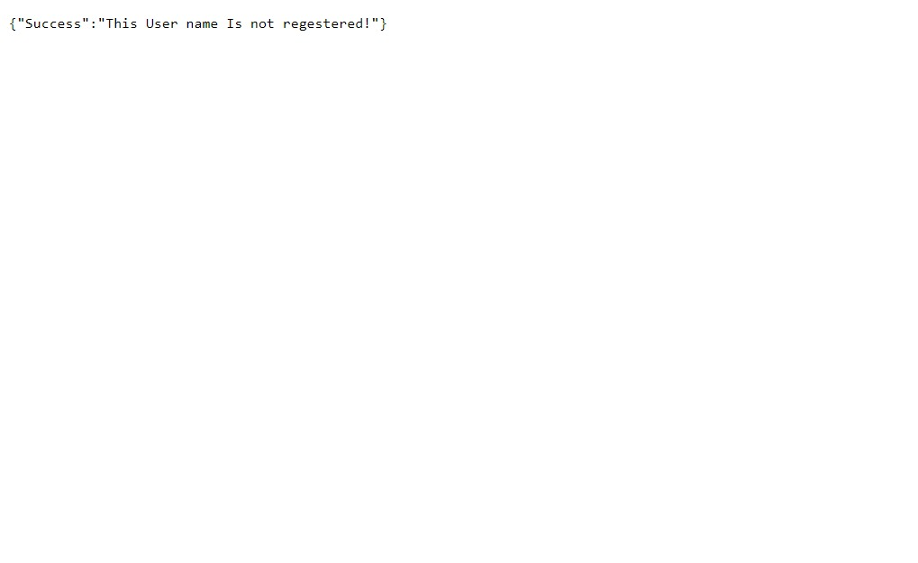

**Test Case 22:**

**View Student Information**

When we provide a valid username and search for it, we get all the general and academic information of the student including CGPA, attendance, fees status, etc.

If we provide an invalid username, then the search is unsuccessful and the system prompts this message.

This shows that test case 22 has passed.

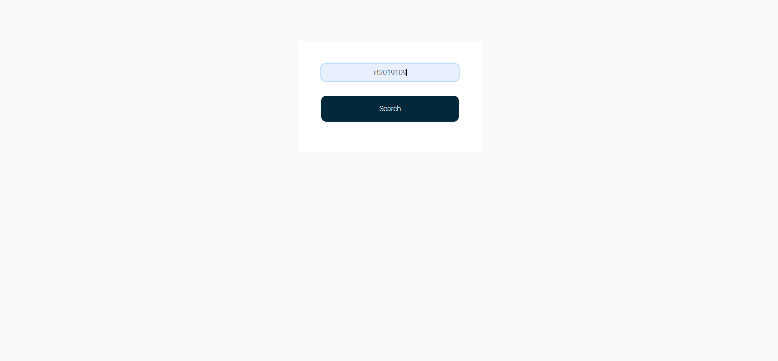



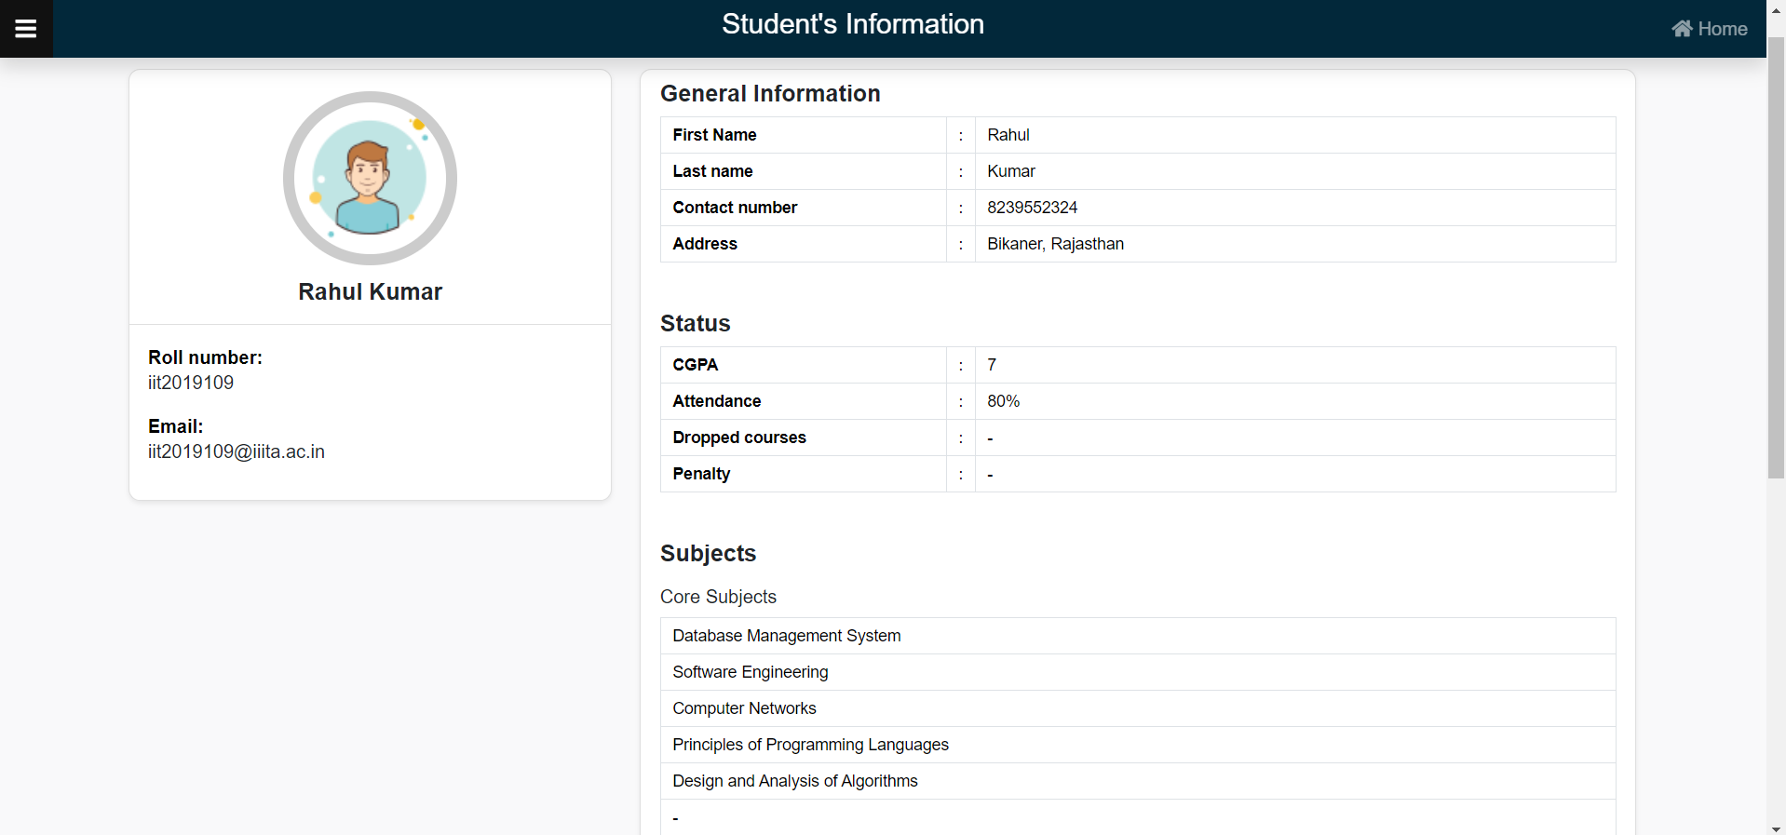

**Test Case 23:**

**Search Result**

The home page for the dean/admin contains multiple options to view and update details such as calendar, timetable, search student.

When we click on the search result, we are redirected to a page that contains an option to enter the student username and search for the marks of that particular username.

If the student entered by the dean is not present in the database , then it shows a message that the student is not registered.

This shows that the test case 23 has passed.

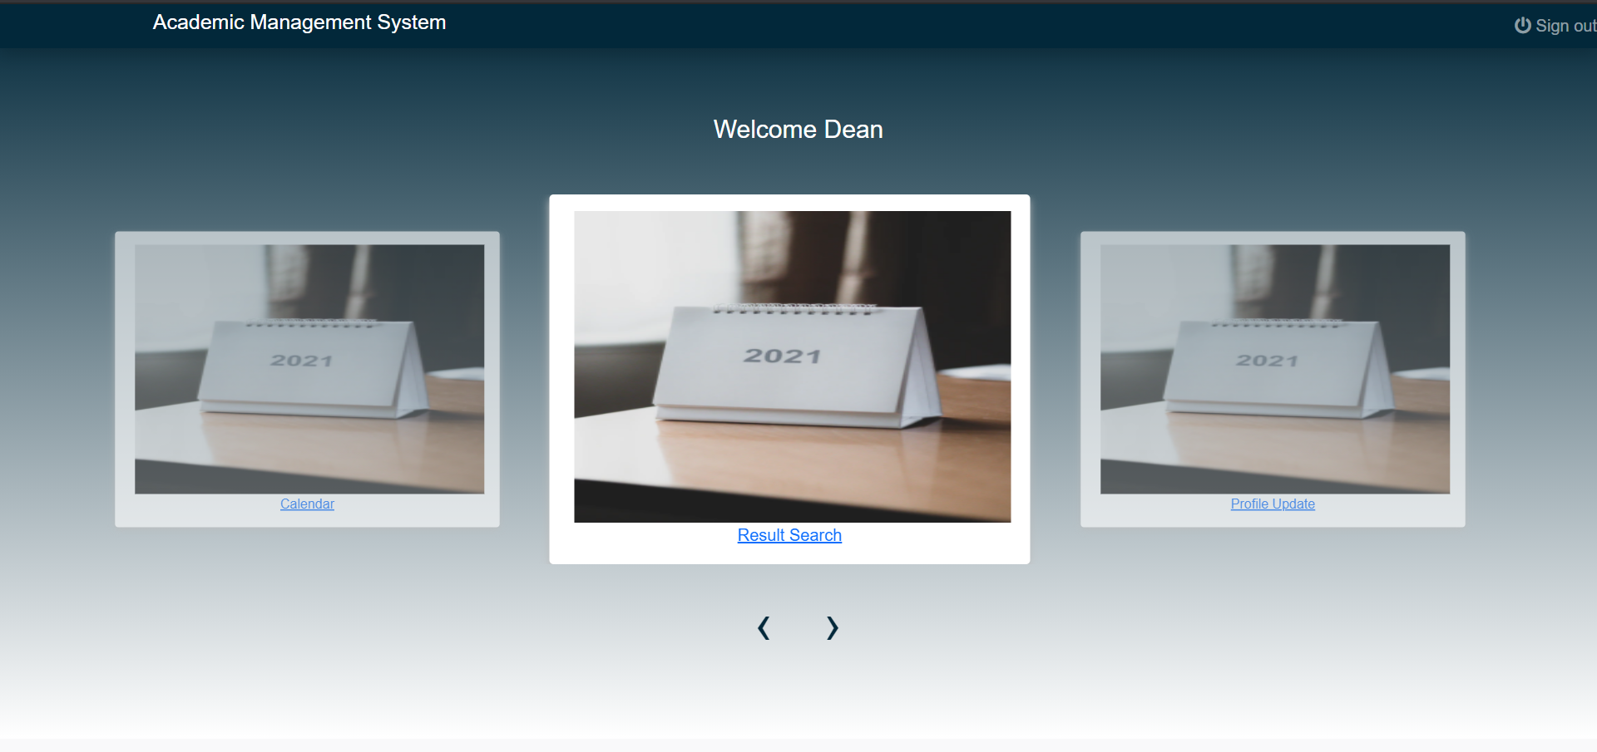



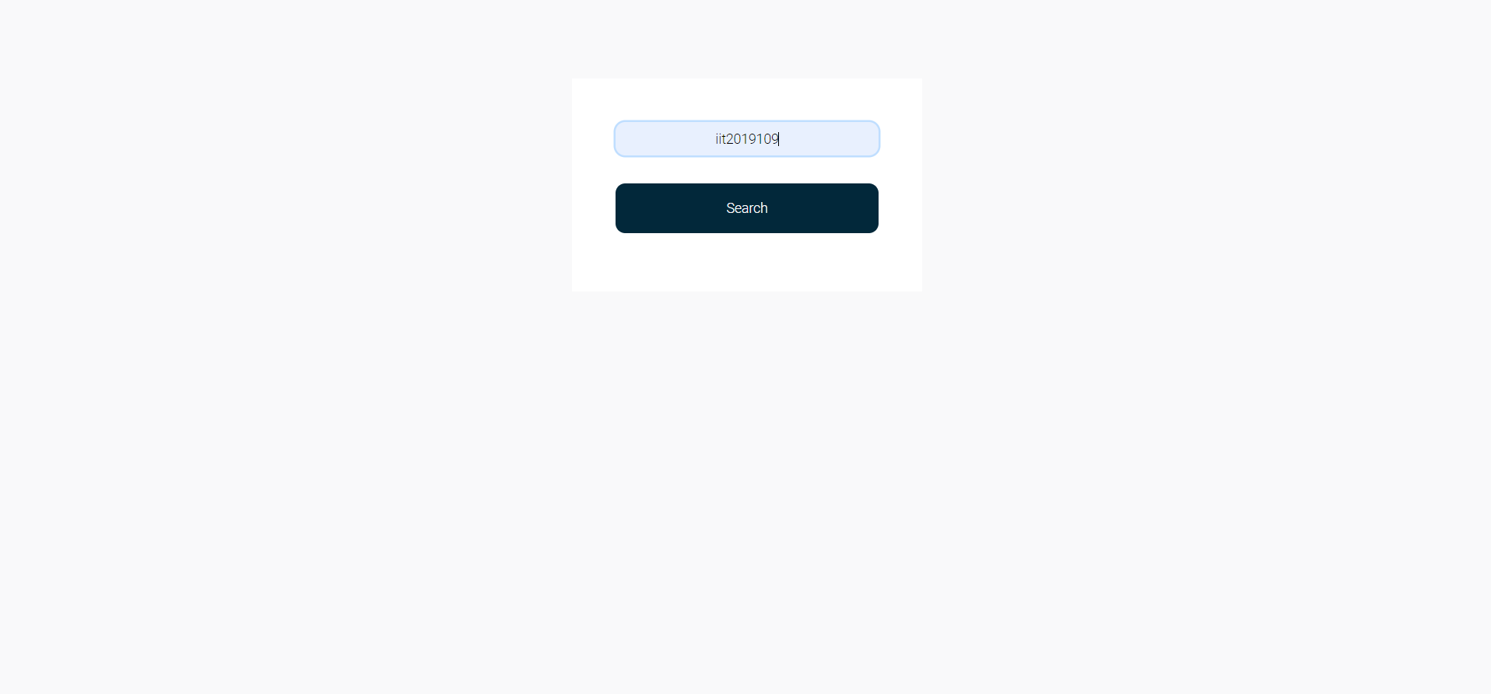



**Test Case 24:**

**View Student Marks**

When we provide a valid username and search for it, we get the marks of that particular username in all the components of all the subjects, electives and projects.

If we provide an invalid username, then the search is unsuccessful and the system prompts this message.

This shows that test case 24 has passed.





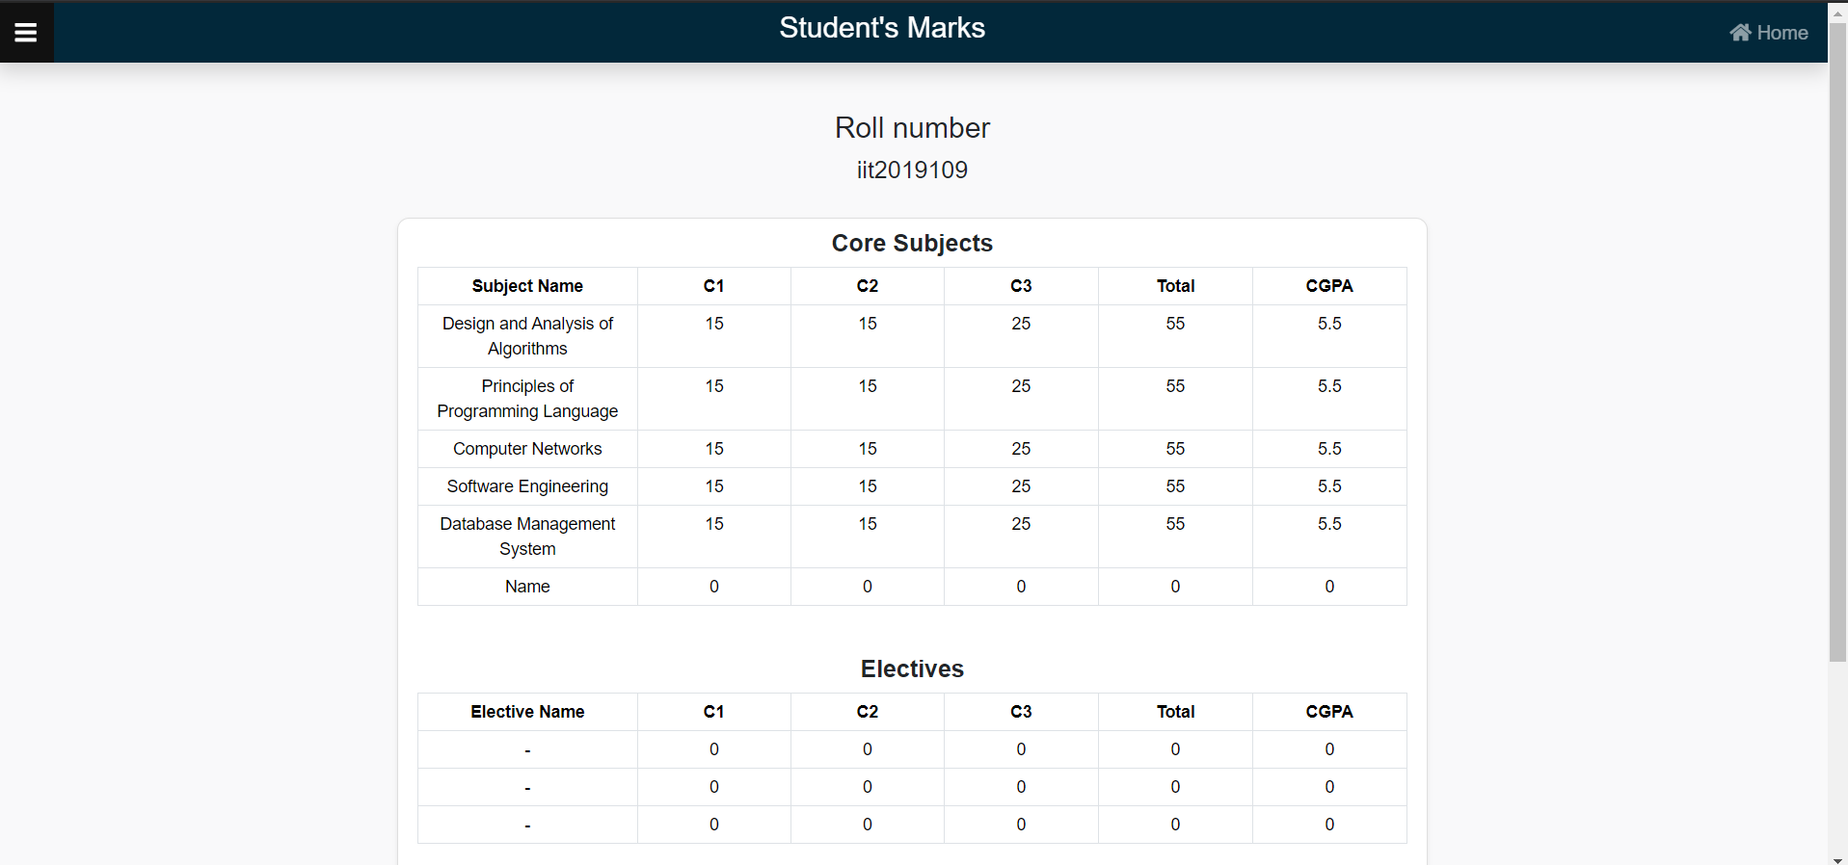

**Test Case 25:**

**Student Profile update**

The home page for the dean/admin contains multiple options to view and update details such as calendar, timetable, search student.

When we click on the student profile update, we are redirected to a page that contains various fields such as username, phone number, attendance, etc. These fields can be filled there and the entered value is updated in the actual database.

If the student entered by the dean is not present in the database , then it shows a message that the username is not found.

This shows that the test case 25 has passed.

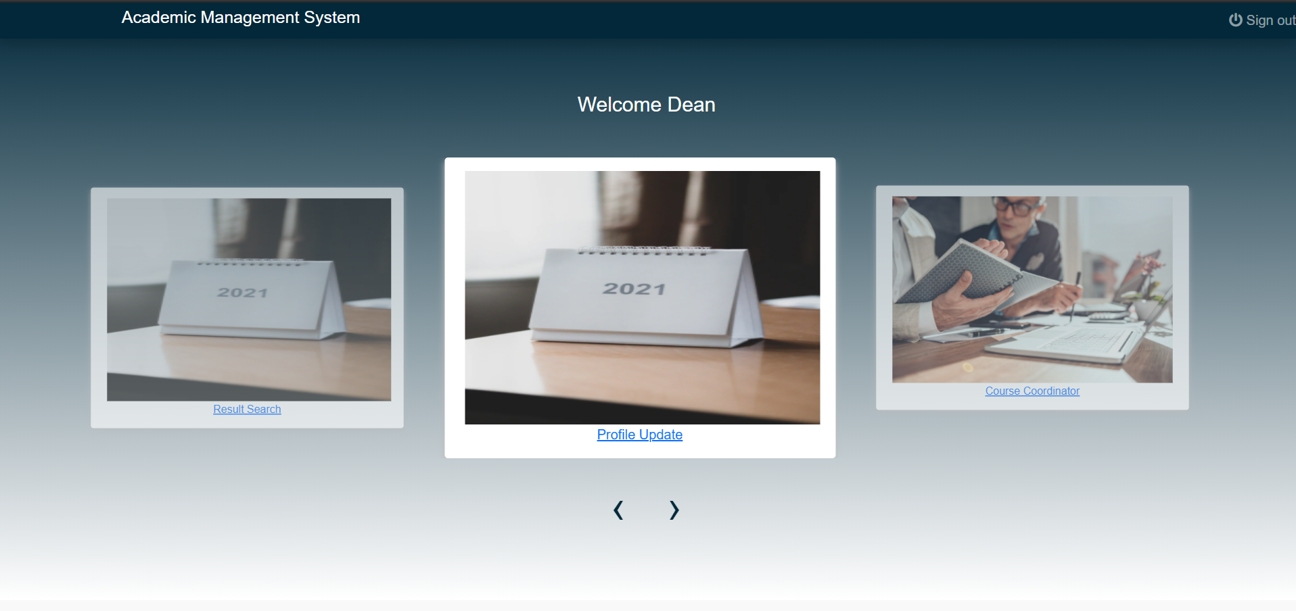



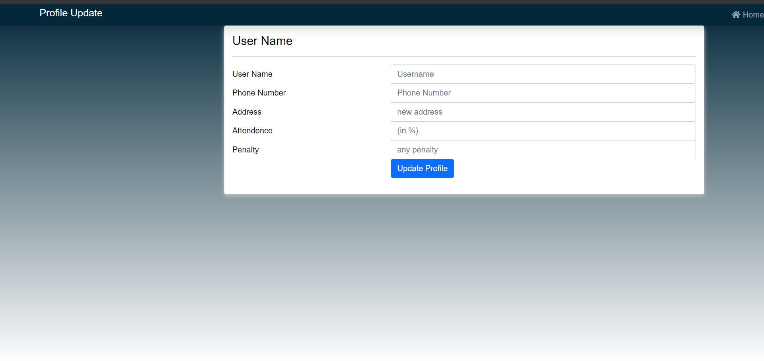

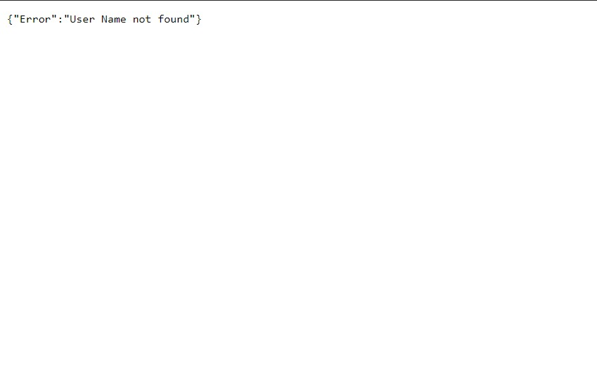

**Test Case 26:**

**Course Coordinator**

The home page for the dean/admin contains multiple options to view and update details such as calendar, timetable, search student.

When the dean/admin clicks on the course coordinators, he is redirected to the page that contains the list of all the coordinators, and clicking on any one of them redirects you to their profile page.

This shows that the test case 26 has passed.

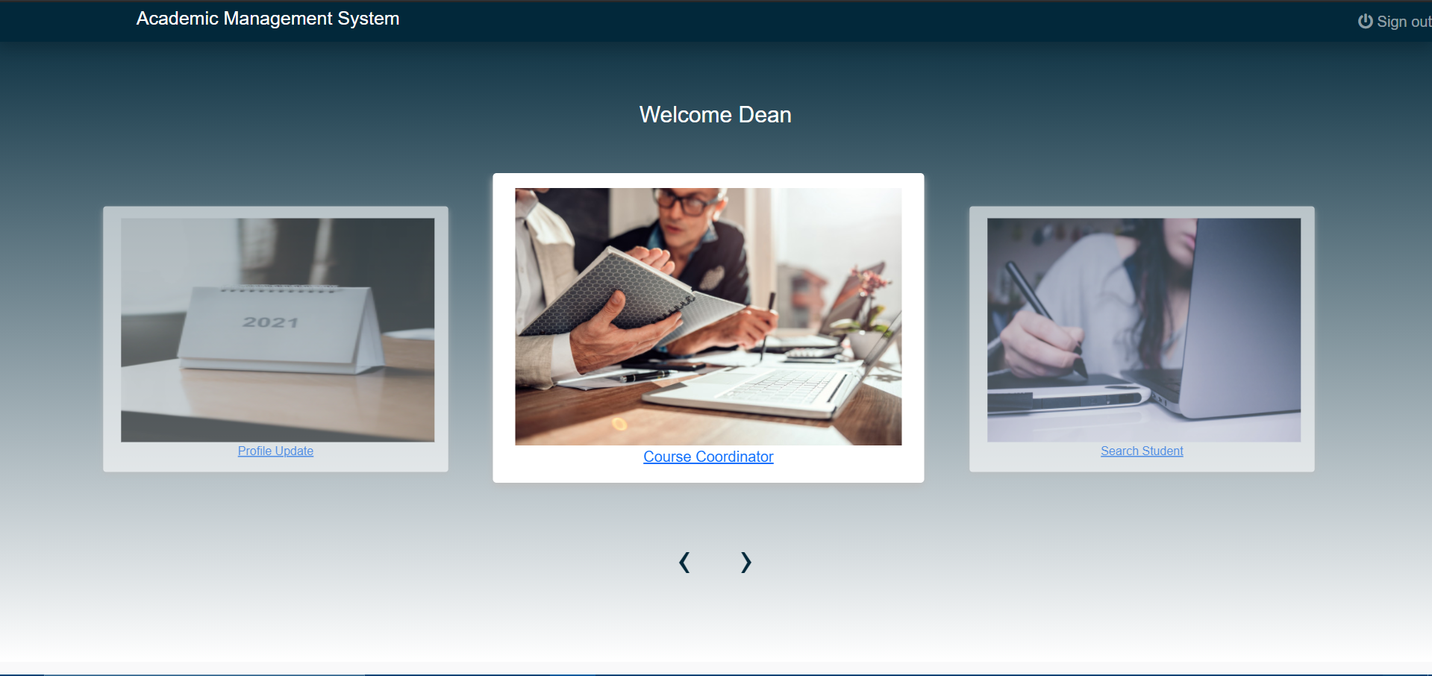



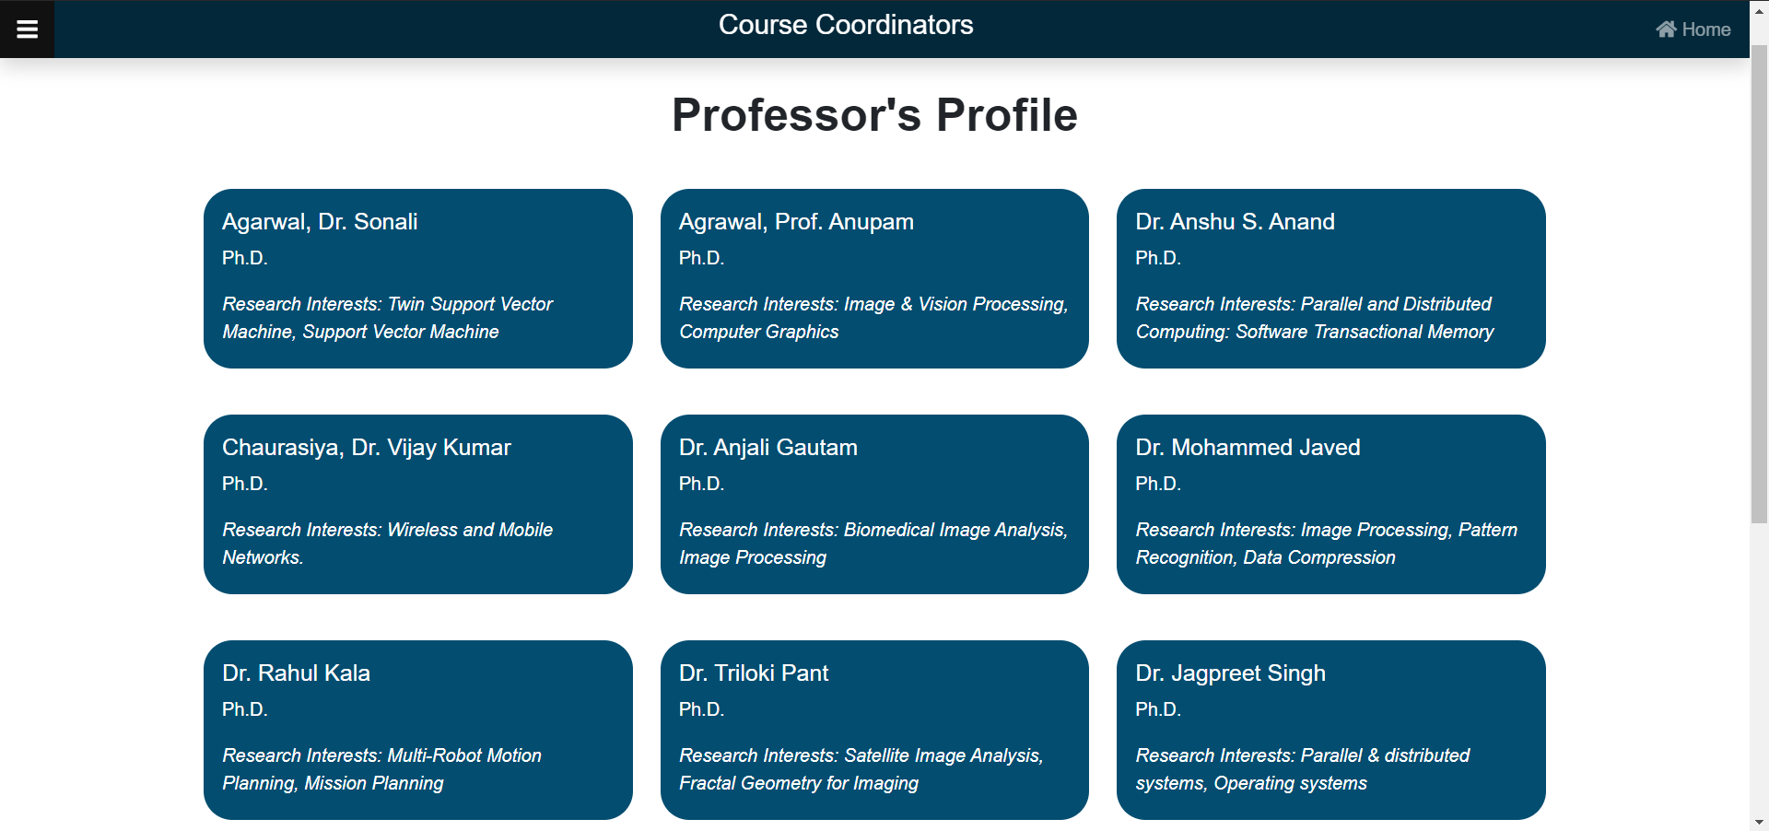

**Test Case 27:**

**Search Subject**

The home page for the dean/admin contains multiple options to view and update details such as calendar, timetable, search student.

When we click on the search course, we are redirected to a page that contains an option to enter the student username and search for all the students that are enrolled in that particular subject.

If the subject entered by the dean is not present in the database , then it shows a message that the subject is not available.

This shows that the test case 27 has passed.

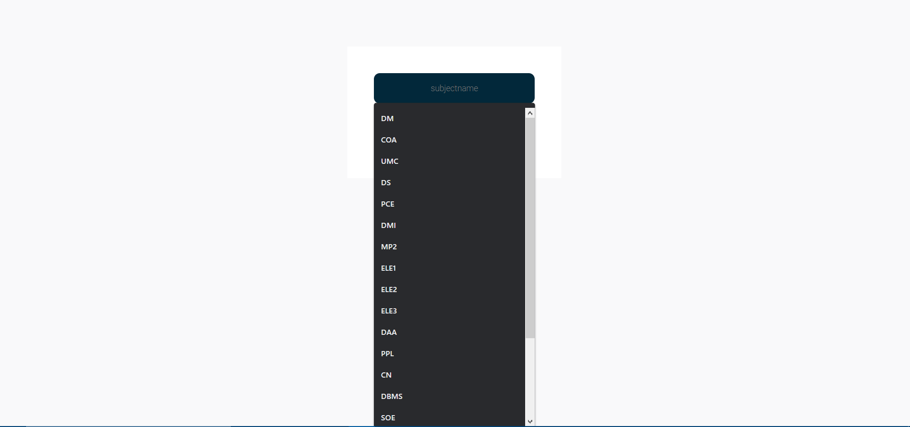



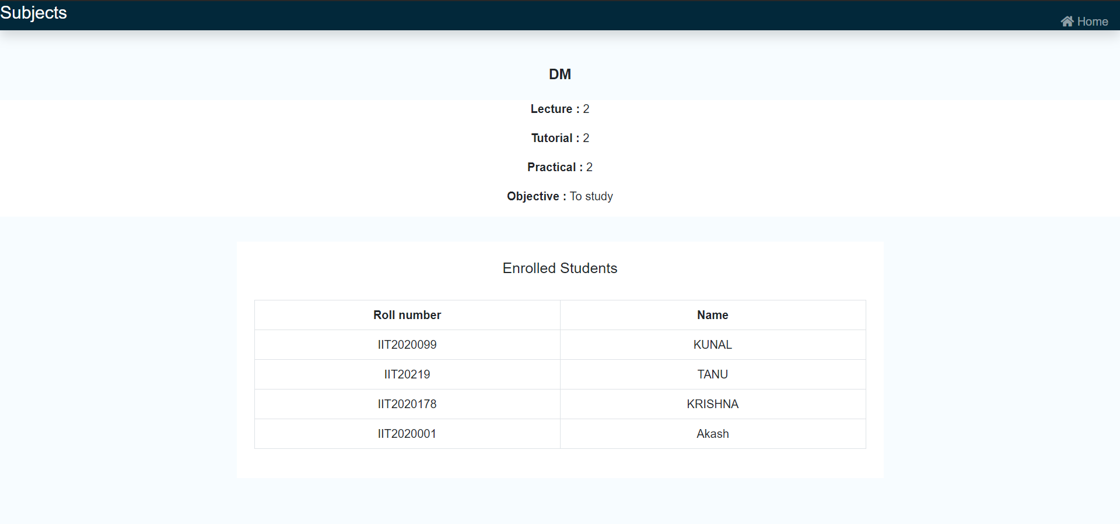

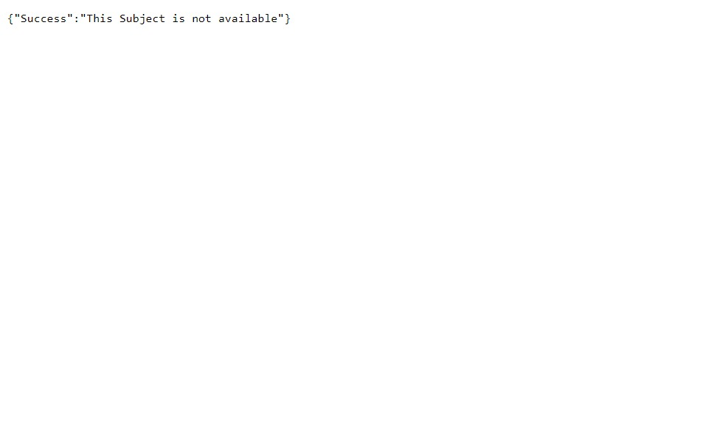

**SECTION 3: INTEGRATE TESTING**

Integration testing, also known as integration and testing, is a software development process in which program units are combined and tested as groups in multiple ways. In this context, a unit is defined as the smallest testable part of an application. In this section, Integration testing has been performed by considering different modules together to see how the module works together.

**COUPLING**

Coupling is the degree of interdependence between software modules; a measure of how closely connected two routines or modules are; the strength of the relationships between modules.

**Test case 1:**

Admin can update the Profile of any student. We expect that if admin update the profile of any student, it will update on the student’s profile page.





Since these related modules, Admin’s module and Student modules are working fine together, hence this test case is passed.

**Test case 2:**

Admin can update the Marks of any student. We expect that if admin update the marks of any student, it will update on the student’s semester result page.

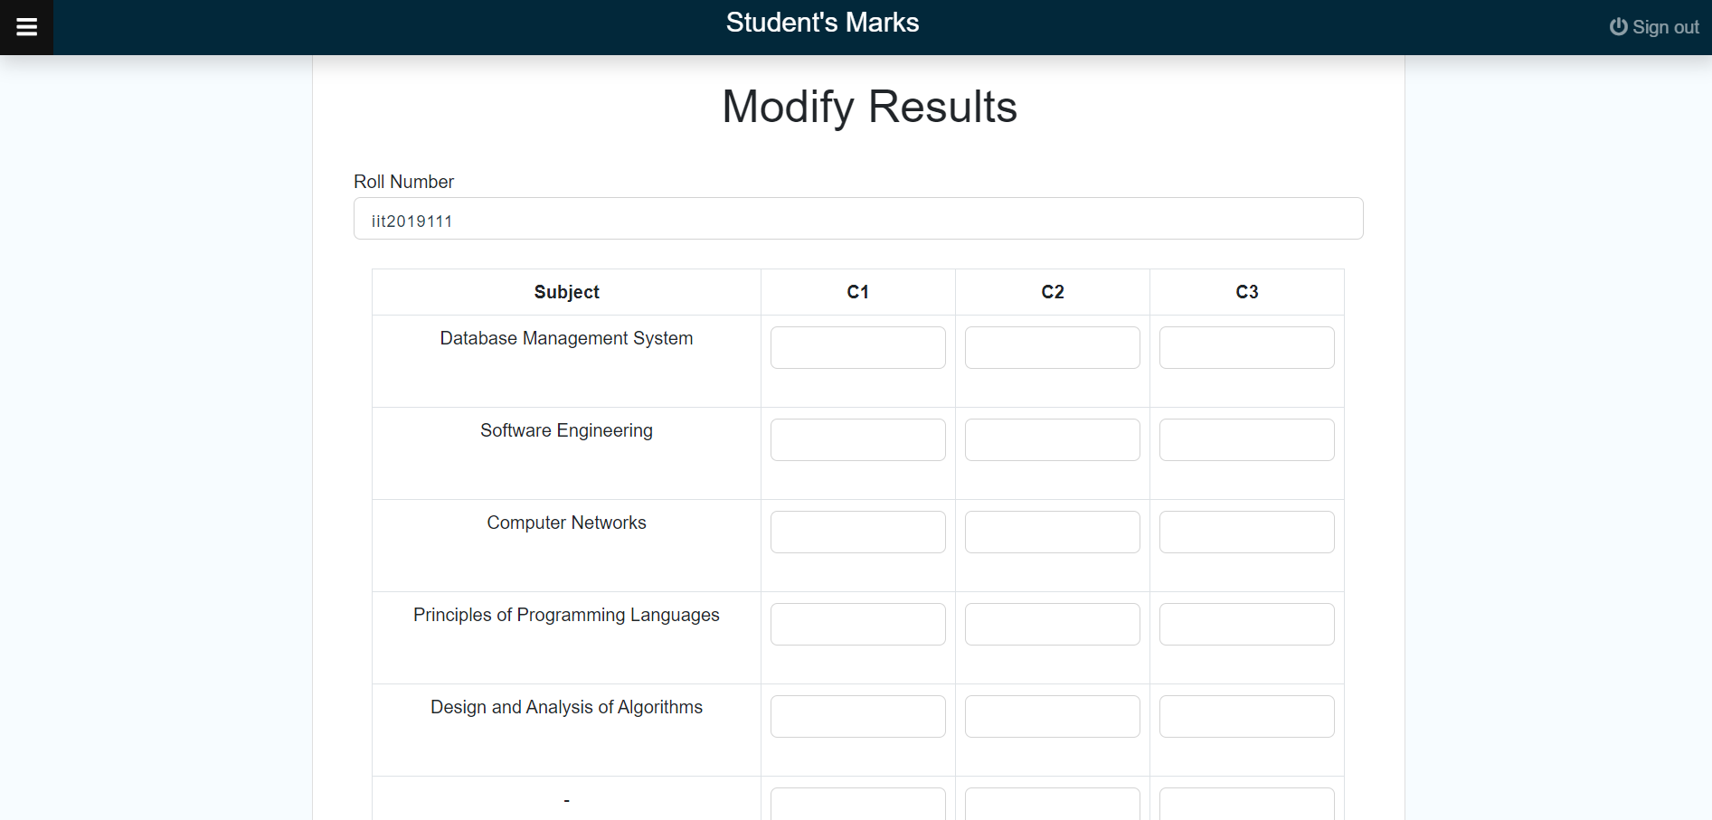



Since these related modules, Admin’s module and Student modules are working fine together, hence this test case is passed.

**Test case 3:**

Admin can update the current academic calender using the feature of upload academic calender and the student can see the updated calender



Since these related modules, Admin’s module and Student modules are working fine together, hence this test case is passed.

**Test case 4:**Admin can update the exam schedule using the feature of upload exam schedule and the student can see the updated exam time table



Since these related modules, Admin’s module and Student modules are working fine together, hence this test case is passed.

**SECTION 4: SYSTEM TESTING**

System testing of software or hardware is testing conducted on a complete, integrated system to evaluate the system's compliance with its specified requirements using SRS. While comparing against the requirements, various scenarios have been generated to know if the there is any bug or not, and various bugs have been found as follows:

**Scenario 1**: Low internet connection, screen is not visible for a long period while loading.

if there is poor network coverage, the loading of image at home screen of admin and the player on login screen is not visible and if the image is deleted from google then also it will not visible

**Errors Found:**

Bug 1 was found during this test.

**Scenario 2**: Logout Navigation problem on Home page.

while you are logged in as a student or admin, pressing back button does not log you off. It rather displays the bank page for the number of times you press the back button.

**Errors Found:**

Bug 2 was found during this test.

**Scenario 3**: Email address authentication

If you enter an email address in uppercase characters then it doesn't matter if the lowercase part is present or not in the database it will give you an error.

**Errors Found:**

Bug 3 was found during this test.

**Scenario 4**: Home Button.

The home button at some places is not working. It is giving a loading tab and after some time it is giving an error.

**Errors Found:**

Bug 4 was found during this test.

**SECTION 5: FOUND AND FIXED BUG**

In this section, the bugs we found during the first execution of test cases are listed. Also the fixes for bugs are listed. All bugs listed here are fixed.

**BUG 1**

**Description:-** It was found that if there is poor network coverage, the loading of images at home screen of admin and the player on login screen is not visible and if the image is deleted from google then also it will not be visible.

**Fix:-**It is advised to use this web application over college Wi-Fi or any internet connection of stronger signal strength.

**BUG 2**

**Description:-** It was found that while you are logged in as a student or admin, pressing back button does not log you off. It rather displays the bank page for the number of times you press the back button.

**Fix:-**It is advised to press the ‘Log Out’ button to log off from the account and not the back button.

**BUG 3**

**Description:-** If you enter an email address in uppercase characters then it doesn't matter if the lowercase part is present or not in the database it will give you an error.

**Fix:-**We use the javascript function toLowerCase() to convert if the email is present in upper character to lower character.

**BUG 4**

**Description:-** The home button at some places is not working they will give a loading tab and after some time they will give an error

**Fix:-** We provide proper router call for each error of this type.